Vertical gradient and foliar trait response of sugar maple to nitrogen and phosphorus
keywords: specific leaf area, twig length, amino acids, chlorophyll a/b/carotenoids

A research proposal
Submitted for consideration of
FNRM M.S. Thesis

Department of Environmental and Forest Biology
State University of New York College of Environmental Science and Forestry
Syracuse, New York

Alexander R. Young
11/28/17

Introduction
In the past half-century Northeastern United States forest have experienced increasing acid rain deposition, nitrogen deposition, and increased atmospheric CO₂ concentration (Galloway et al. 2003). Acclimation to disturbance can be observed in nutrient allocation above or belowground, and may be especially visible if N enrichment induces secondary limitations to plant productivity (Naples and Fisk 2010) or if N limitation is converted to P limited plant productivity (Vitousek et al. 2010). This should be especially visible in sugar maple (Acer saccharum) as it is a particularly environmentally sensitive species (Gradowski and Thomas 2006, Long et al. 2009).
Plant productivity can be limited by irradiance, water availability, and nutrient availability (Grime 1977). Plasticity in allocation patterns may allow plants to shift in response to their environment over time and is likely related to the species environmental tolerance (Liu et al. 2016). According to the balanced-growth hypothesis, plants will preferentially allocate biomass to acquire the most limiting resources (Shipley and Meziane 2002).
A greater understanding of nutrient cycling and acclimation to disturbance in Northeastern forests will improve management decisions, conservation efforts, and increase our understanding of nutrient mediated plasticity in biomass allocation and utilization (Poorter et al. 2011). For example- seven years of fertilization with N, P, or both may initiate aboveground tree response in the vertical distribution of foliar traits by their altering specific leaf area, palisade mesophyll thickness, chlorophyll concentration, free amino acid concentration, and/or nitrogen content.
Specific leaf area investigation
The specific area of a leaf (sla) is a ratio of leaf area to mass, wherein the surface area (cm²) is divided by the dry weight (g) of leaves. The surface area of a given leaf is constrained at a threshold because the biomass investment per unit leaf area becomes restrictive.
Specific leaf area decreases with height in a tree canopy (Marshall and Monserud 2003). One potential acclimation to nutrient perturbation could be thinner, more compact leaves.
Specific Twig Length & Diameter Investigation
Aside from foliar adjustments in biomass allocation, another aboveground response may be seen in the specific twig length throughout the canopy gradient. Specific twig length is calculated by the length of a twig node (cm) divided by the dry mass of the twig (g) (Schmitt et al. 1999). As light travels towards the ground its intensity attenuates making the positioning of leaves at the top of the canopy of utmost importance for maximum light interception. With competition from other trees and self-shading factors, stem length elongation may offer direct advantages to increasing carbon assimilation. This may cause a trade-off of fast growth and more brittle wood, resulting in longer but thinner twigs.
Chlorophyll a/b ratio Investigation
The ratio of Chlorophyll a (the major photosynthetic pigment on photosynthesis) and chlorophyll b may be a useful indicator of N partitioning (Hikosaka 1995). In sun leaves with high irradiance availability, Chlorophyll a/b ratio should increase (Hogan 2003). However, Chlorophyll a/b may also increase with decreasing N availability, a response that maximizes Chlorophyll a concentration over the secondary chlorophyll b protein (Hidaka and Kitayama 2009) even though the range of light absorption is slightly extended by chlorophyll b and carotenoid pigments. While photosynthetic pigments are N rich, there may be a phosphorous limiting rate to sugar maple photosynthesis which would constrain polysaccharide quality (Finzi 2009, (Ellsworth et al. 2015).
Amino Acid and Poly-amine concentration
Amino acids are primarily composed of carbon, hydrogen, oxygen, and nitrogen. In addition to photsynthetic compounds, amino acids are densely packed with nitrogen. Of the amino acids there are essential amino acid, proteinogenic and non-proteinogenic acids, and Gaba may be a signaling agent in anion transport (Ramesh et al. 2015).
Objective
The goal of this study is to examine the response of biomass allocation after seven years of nutrient amendment with N (30 kg/ha NH₄NO₃₎, P (NaH₂PO₄₎, and both N and P on foliar traits and their distribution through the canopy. Stratified leaf collection may help visualize the interaction of light availability, nutrient mediated productivity, and subsequent strategies of biomass allocation.
Methods
Field site and sample collection
Three stands in Bartlett Experimental Forest (White Mountains National Forest, NH, USA) were used for this study (Figure 1). The experimental nutrient treatments were established in 2011 with the Multiple Element Limitation in Northern Hardwood Ecosystems. The climate for the region is humid-continental and receives 1400 mm of rain per year and has a mean temperature of 5˚ C (Bailey et al. 2003).
Branches with foliage were collected using a pole pruner from mature sugar maple trees from stands last harvested ~100 years ago. Branches were collected along vertical transects from the top (sun-lit) canopy to the lowest foliage in two meter increments. Healthy leaves void of insect damage or disease were removed from branches where the petiole joins each twig, then stored in zip lock bags with a moist towel in a refrigerator. Branches were broken into 20 cm in length sections and air dried at room temperature.
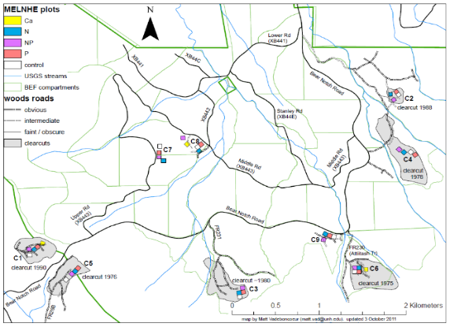
Figure 1. A map of Bartlett Experimental Forest, with stands C7, C8, and C9 circled in blue.

Table 1. Summary of the twelve sugar maples climbed from 10 am to 4 pm on 7/31/17 and 8/1/17.
Stand | Treatment | Tree.ID | DBH.cm | Height.m | # of samples
C7 | control | 480 | 59.3 | 24 | 7
C7 | nitrogen | 609 | 42.6 | 20 | 4
C7 | phosphorous | 571 | 64.5 | 24 | 4
C7 | nitro_phos | 1297 | 49.3 | 20 | 3
C8 | control | 250 | 50.7 | 25 | 5
C8 | nitrogen | 30 | 40.8 | 23 | 4
C8 | phosphorous | 249 | 49.5 | 24 | 6
C8 | nitro_phos | 928 | 52.9 | 25 | 5
C9 | control | 79 | 55.7 | 25 | 5
C9 | nitrogen | 320 | 44 | 24 | 6
C9 | phosphorous | 128 | 59.8 | 23 | 5
C9 | nitro_phos | 168 | 53.8 | 22 | 6
 |  |  |  |  | Total = 60

Specific Leaf Area Method
Zip-lock bags with leaves were taken out of refrigerator and emptied onto a table. The pile was quartered, and 10 leaves were chosen at random from adjacent corners of the cone. Leaves were pressed and placed onto a flat surface with a ruler before being imaged with a Nikon camera. The 10 resulting leaves were then inserted into a large coin envelope, labeled, and oven dried until at constant dry-mass.
Surface area of the ten leaves per sample was measured using ImageJ software. Each image was calibrated individually using the ruler in the image. A polygon was drawn around the 10 leaves, and the area was calculated with 10 leaves detected in each image.
Oven-dried coin envelopes containing leaves were weighed to the hundredth of a gram, and oven-dry coin envelope mass was subtracted from the recorded leaf and envelope mass. Specific leaf area was calculated as the surface area of the 10 leaves (cm²) divided by the mass of the 10 leaves (g).
Paraffin Method
Before fixation a razor blade was used to isolate a 0.5 x 0.5 cm sections of leaf from the midpoint of leaf tip and base. Leaf tissue was fixed in FAA (formalin-Acetic-Alcohol), dehydrated in Johansen’s alcohol series, infiltrated and embedded in paraffin, sectioned using a rotary microtome, then stained using aqueous Toluidine blue dye. Five sections (one per leaf) were placed into a small vial, filled half way with FAA and capped with a cork. After 24 hours, each vial was rinsed five times with distilled water allowing a half hour between rinses.
Water was removed from the samples and vials through a series of increasingly alcoholic solutions (Johansen 1940). Complete removal of all water from the samples and vials is required because the embedding media (paraffin) is hyrdrophic will not form a support the interstitial leaf anatomy if water is present.
Table 2. Johansen’s alcohol series with amount of time in each solvent.
Series Number  Amount of Time | 1  1-2 hours | 2  overnight | 3  1-2 hours | 4  1-2 hours | 5  1-2 hours | 6  X3 total 16 hours
Alcohol concentration | 50 | 70 | 85 | 95 | 100 | 100
Distilled water | 50 | 30 | 15
95% ethyl alcohol | 40 | 50 | 50 | 45
Tertiary butyl alcohol | 10 | 20 | 35 | 55 | 75 | 100
100% ethyl alcohol |  |  |  |  | 25
To distribute the paraffin media uniformly throughout leaf tissues the anhydrous solvent TBA (tertial butyl alcohol) was replaced with liquid paraffin. Leaf samples in vials with Johansen’s series 6 were poured into a vial containing 1/3 hardened paraffin then placed into an oven at 58˚ C for two hours. The paraffin/TBA mixture was replaced with liquid paraffin two more times over the course of 24 hours.
To embed leaf tissue liquid paraffin was poured into a paper trough, leaf samples were added, additional wax was added, then cooled resulting in a block of wax. The paper trough was created using an index card, and was filled to 2 mm with paraffin. Samples were positioned in line with adequate spacing between the three leaf tissues. Additional paraffin was poured into the trough, allowed to cool on ice water for 15 minutes, then sunk in ice water and stored in a refrigerator.
Sections of leaves were sliced to 5 microns using a rotary microtome. Slides were prepared with a light application of Haupts adhesive (1 g Knox gelatin, 15 ml glycerol, 100 ml distilled water), ribbons of paraffin sections were placed onto slides, then stained in 0.05 % aqueous toluidine blue die for 30 minutes. Paraffin was removed with 100% ethyl alcohol for 1 minute, a 1:1 solution 100% ethyl alcohol to histoclear, and then 100% histoclear for 3 minutes. Slides were mounted with a drop of permount medium and covered with a 60 x 24 mm coverslip.
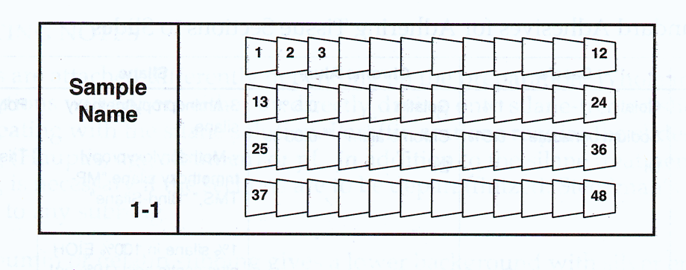
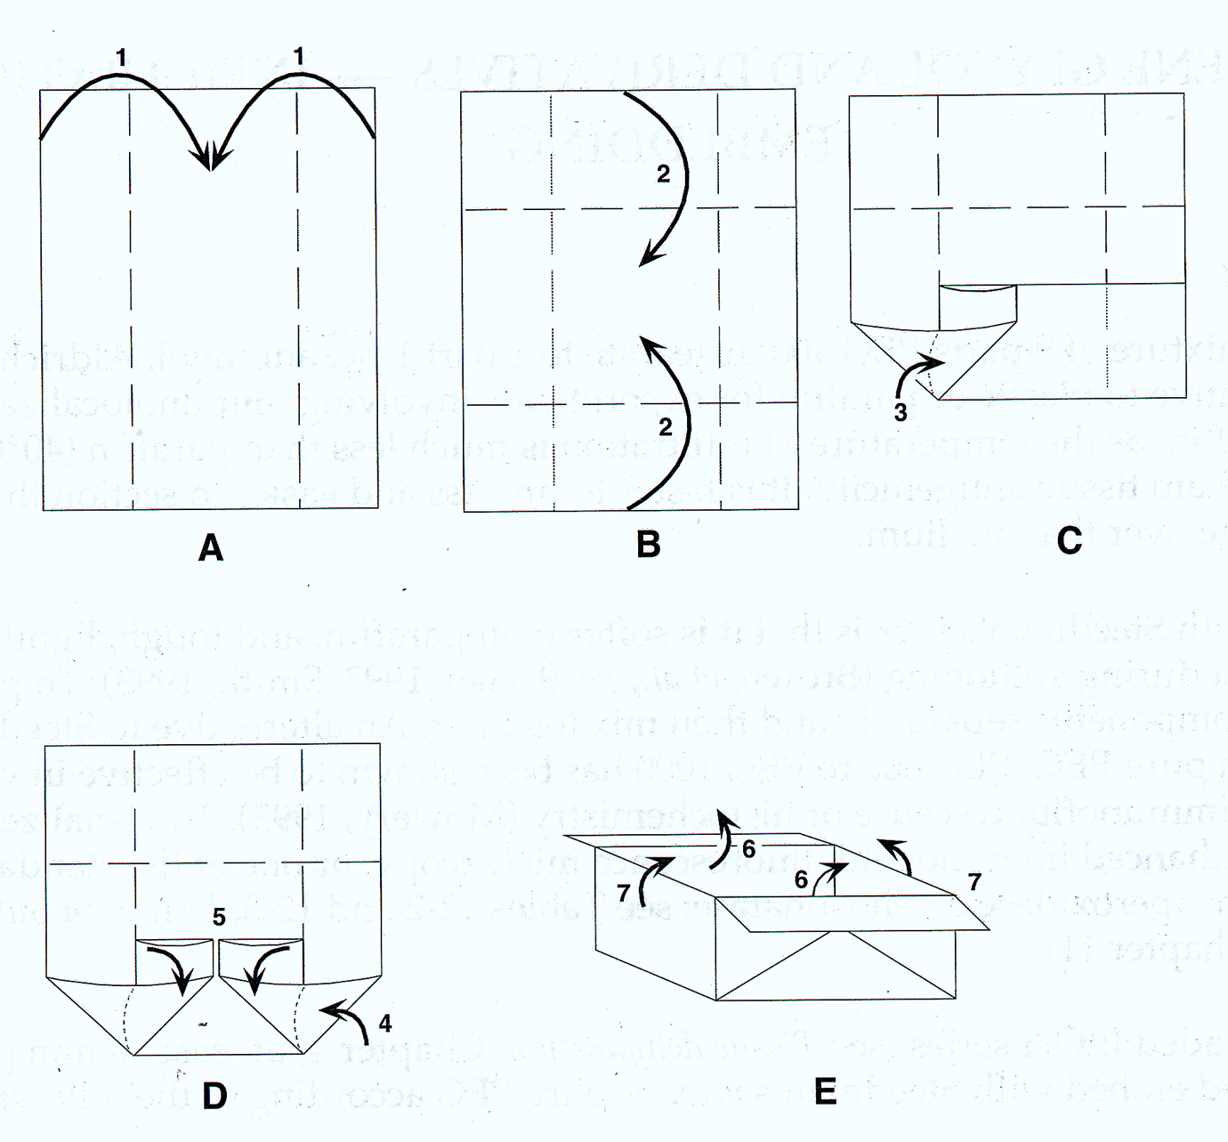

Figure 3. How to make a paper boat (left). Example slide layout with sections of leaf (right).

Twig Methods
Sections of twigs were broken at 3 and 10 years prior to collection. Twig sections were fixed with FAA, brought to 100% alcohol, then sectioned to 35 microns using a sliding microtome. Ten sections per twig were collected in a vial with 70% Ethanol (EtOH) then drained. Two drops of 68% EtOH Safranin Orange die was added for three minutes, rinsed with 70% EtOH, 95% EtOH, 100% EtOH, a 1:1 solution of 100% EtOH and histoclear. then 100% histoclear. Five twig sections per vial were mounted onto glass slides with a drop of permount mounting medium then kept on a warm plate.
A better method for fixation should/could be used. The bark came off the twigs in a number of samples. Here are two examples (figure XX).
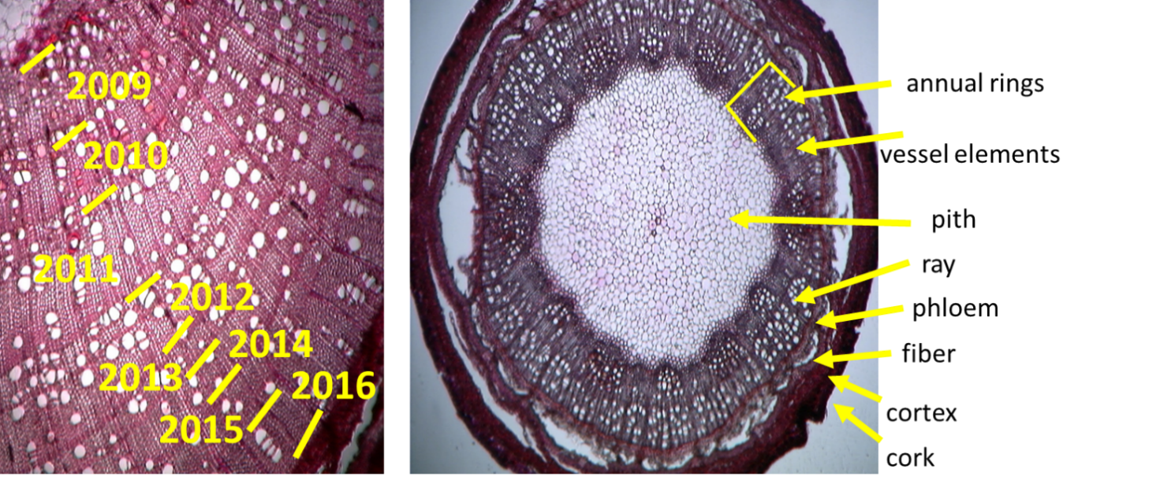
Figure XX. Twig anatomy with 7 years of labeled annual growth (left). Twig anatomy (right).

Metabolism Methods
Three leaves per branch (height) were hole-punched into two micro-centrifuge tubes until about 1/3rd full. One micro-centrifuge tube was then filled with 1 mL Perchloric acid (PCA). Microcentrifuge tubes were stored on ice in the field, immediately transferred to a freezer, then transported to the Durham, NH USFS lab, and Dr. Rakesh Minocha and Stephanie Long performed subsequent analyses.
- Free amino acid and polyamine concentration per fresh weight leaf tissue.
  - Completed, included in results
- Chlorophyll a, b, and total carotenoids per fresh weight leaf tissue
  - Completed, included in results
- Soluble Ions
  - Not completed yet. Estimated completion January/February 2018

%C/N, ICP
Oven-dried leaves will be ground using a wiley mill, sieved with 40 µm mesh, then stored in glass scint vials. Labels will be pre-printed for each scint vials (figure X). The procedure will include ashing leaf material, acid-digestion, and ICP analysis. Quality control will include two apple 1515 apple tissue samples, a duplicated sample, and a blank.
Figure 4. Example label template for scint vials.

An initial batch of 36 sample (of 60) could be run on ICP. If the top two samples, and lowest sample of each tree were included, then a convenient 3 samples times 12 trees= 36 samples, with 4 quality control samples (2 apple 1515 standards, 1 blank, 1 duplicate) would be 40 samples.
It may be that %C/N would be cheaper at a different institution. Alex will explore options for where it might be cheaper than $10 a sample.
Twig Growth Rate Method
The inter-node distance and inter-node mass of each twig will be measured to determine if there is a treatment effect on the specific twig length. With the help of undergraduates, 5 twigs will be measured per canopy height. Specific twig length is calculated as the length (cm) divided by mass (g).
Table 2. Example dataset for specific twig length.
Stand | tree | height | treatment | Twig No. | Year of growth | length | Mass | Ratio
C7 | 480 | 24 | Control | 1 | 2016 | l | m | l/m
C7 | 480 | 24 | Control | 1 | 2015 | l | m | l/m
C7 | 480 | 24 | Control | 1 | 2014 | l | m | l/m
… | … | … | … | … | … | … | … | …
C7 | 480 | 24 | Control | 3 | 2016 | l | m | l/m

Statistical analysis methods
A mixed effect model will be used to assess the N by P factorial with trees nested in stands. So far only single dependent variables have been tested against N treatment, P treatment, N*P treatment, distance from the top of tree, and the interaction of treatment on distance from top of tree. The statistical program R was used for all analyses alongside packages lme4, visreg, plotrix, and ggplot2(Wickham 2009, R Core Team 2017).

Mixed effect model: Factorial with trees nested in stand
dep.var ~Ntrmt+Ptrmt+Ntrmt:Ptrmt+dfromtop+ Ntrmt:dfromtop+Ptrmt:dfromtop+(1|Stand/Tree.ID

Results

The twelve sugar maples had ten meters of vertical transect length producing 5 samples on average per tree. Anatomic traits including specific leaf area and palisade mesophyll thickness were higher in plots treated with nitrogen and phosphorous. In contrast, the amino acid concentration and chlorophyll a, b, and total carotenoids were higher with N treatment, and there was no response to P additions.

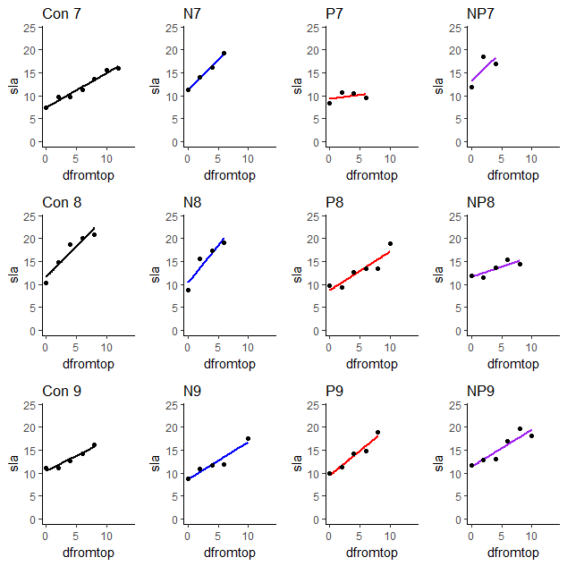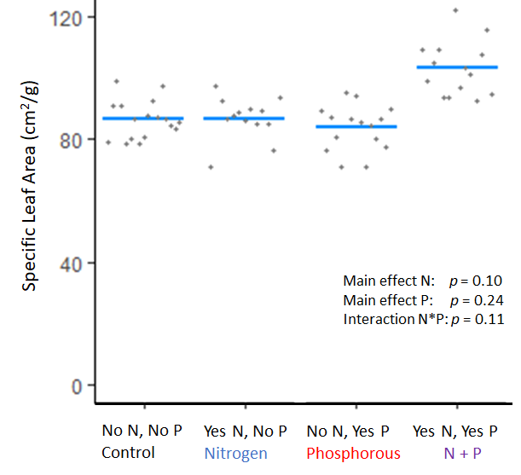

Figure 5. Specific leaf area per tree, Each point is a zip-lock bag (left). Predicted values from mixed effect N*P factorial model (right).
Figure 6b. Palisade mesophyll length measurement.
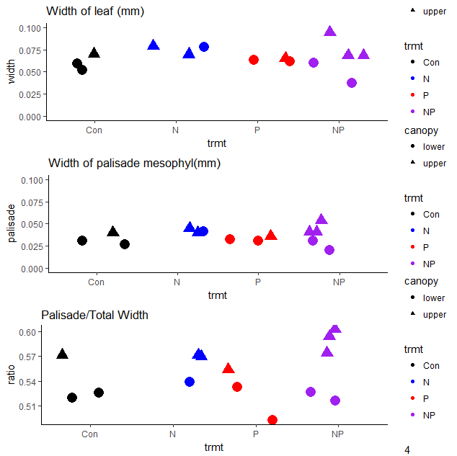
Figure 6. Leaf width, palisade mesophyll width, and the ratio palisade:mesophyll length to leaf width is graphed across each nutrient treatment. Upper leaves are different than lower leaves ( p = 0.02), trees that were treated with NP had marginally wider palisade mesophyll (p = 0.08).

The amino acid and polyamine method provided data on metabolism but many amino acids were below detection level (table 3.) Three out of 23 amino acids are above the detection limit. Many show a consistent pattern of a main N effect when analyzed with a mixed effect N*P factorial model (Figure 7). There is a strong interaction between canopy depth and Nitrogen treatment on nearly all useable amino acids. Leaf chlorophyll content was also strongly associated with canopy depth, and responded with increased chlorophyll a, b, and total carotenoids (figure 8).

Table 3. List of Amino acids with comments in detection limit.
Abbrev | Full name | Useable? |  | Abbrev | Full name | Useable?
Asp | Asparagine | yes |  | Ile | Isoleucine | yes
Glu | Glutamic acid | yes |  | Leu | Leucine | yes
Gln | Glutamine | no |  | Trp+Phe | Threonine | yes
Ser | Serine | yes |  | Cys | Cysteine | ***
Arg | Arginine | no |  | Orn |  | ***
Thr | Threonine | no |  | Lys | Lysine | yes
*Gly | Glycine | no |  | His |  | ***
Ala | Alanine | yes |  | Put | Putrescine | yes
Pro | Proline | no |  | Spd |  | yes
Gaba | Gaba | yes |  | Spm |  | ***
Val | Valine | yes |  | a-PHE.area | yes
Met | Methionine | no

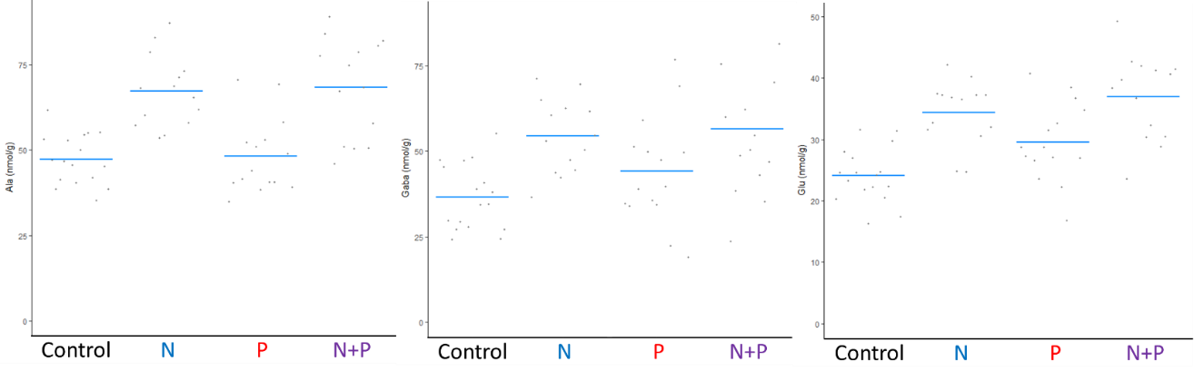
Alanine, Gaba, Glutamatic acid concentration (nmol/g Fresh Weight)
Figure 7. Amino acid concentration Alanine, Gaba, and Glutamic acid across nutrient treatments.

Chlorophyll a, b, and total carotoneids also demonstrated a main nitrogen treatment effect (figure 8).

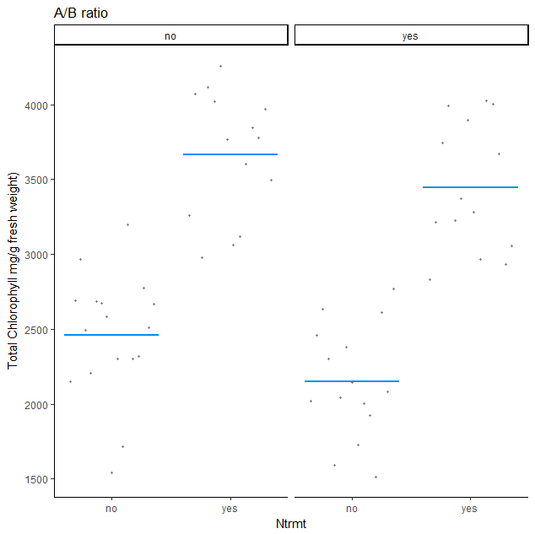
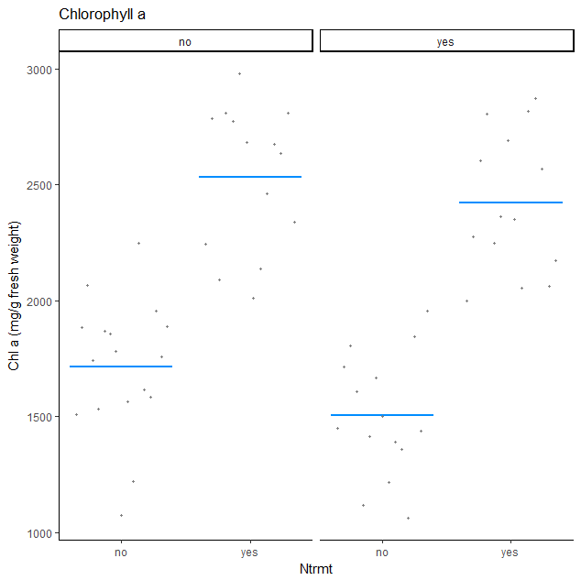
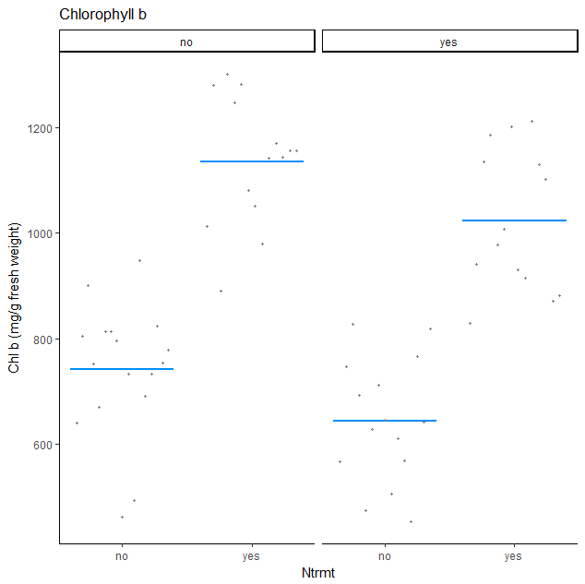
Figure 8. Chlorophyll and total carotenoid concentration from predicted values of a mixed effect N*P factorial model using uv-vis spectroscopy ((Lichtenthaler and Buschmann 2005).

Control N P NP
Control N P NP
Control N P NP
Control N P NP
Control N P NP
Control N P NP
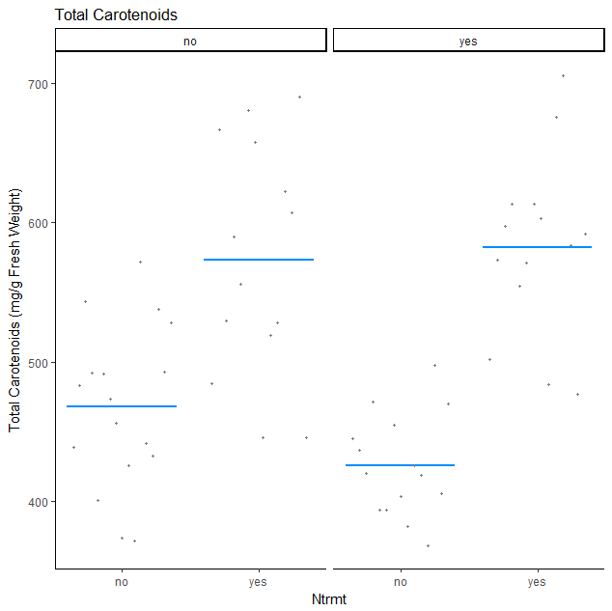

Discussion

Phenotypic adjustments associated with nutrient addition could represent a release from nutrient limitation. The anatomy of tree organs may prove illustrative of further phenotypic response. Previous evidence of element limitation in northern hardwood ecosystems include foliar resporption rates, basal growth rate, phosphorus recycling, and sap sweetness (Gonzales Unpublished, Goswami Unpublished (See et al. 2015, Wild and Yanai 2015).
Alterations in specific leaf area may be reflective of leaf age, increased turgor pressure during leaf expansion, more densely packed palisade mesophyl, or a higher starch content.
Increased amino acid concentrations upon 7 summers of 10 kg/ha/yr of Nitrogen addition may be explained by energetic cost of amino acid synthesis.
Interestingly, the structural analysis of SLA and palisade width may be co-limited by N and P, and metabolic adjustments follow a main N effect.

Monetary Budget

 |  | Cost/sample | # of samples |  | Total cost
Grinding |  | 1.34 | 60 |  | 80.40
ash&digest |  | 3.18 | 60 |  | 190.80
ICP |  | 2.25 | 60 |  | 135.00
% C/N |  | 10.00 | 60 |  | 600.00 | # word of mouth quote- will confirm the cost.
scint vials |  | 0.33 | 60 |  | 19.80
Ethanol 70% |  | 15.00 | 1 |  | 15.00
Absolut 100% |  | 31.00 | 1 |  | 31.00
Slides |  | 4.75 | 1 |  | 4.75
 |  |  |  |  | $1,076.75

Time Budget

For ICP analysis
Grinding 60 samples = ~ 10 hours
Ashing 28 ICP hours = 12 hours on-site, 1 in morning.
Digesting 28 ICP samples = 8 hours
ICP machine operating 28 samples = 6 sets of ~45 minutes = 4.5 hours.

Total ICP time = ~36 hours.
For Microtome sectioning
Fixing leaves, alcohol series = 8 hours over 2 weeks (overnights included)
Setting into wax = 5 minutes/sample = 10 hours
Microtome sectioning = 20 hours
Image Analysis = 2 minutes /sample = 2~ hours

Total microsection time = 40 hours.

Expected dates of completion
- Form 3B- Fall 2017
- Capstone- Spring 2018 (in April?)
- Preliminary thesis submission May 2018
- Final thesis submission September 2018
- Degree complete Dec 15th 2018.

Works cited
Bailey, A., J. W. Hornbeck, C. L. John, and E. Christopher. 2003. Hydrometeorological Database for Hubbard Brook Experimental Forest: 1955 – 2000 The Authors. USDA Northeastern Research Station.
Ellsworth, D. S., K. Y. Crous, H. Lambers, and J. Cooke. 2015. Phosphorus recycling in photorespiration maintains high photosynthetic capacity in woody species. Plant, Cell and Environment 38:1142–1156.
Galloway, J. N., J. D. Aber, J. W. Erisman, S. P. Seitzinger, R. W. Howarth, E. B. Cowling, and B. J. Cosby. 2003. The Nitrogen Cascade. Source: BioScience 53:341–356.
Gradowski, T., and S. C. Thomas. 2006. Phosphorus limitation of sugar maple growth in central Ontario. Forest Ecology and Management 226:104–109.
Grime, J. P. 1977. EVIDENCE FOR THE EXISTENCE OF THREE PRIMARY STRATEGIES IN PLANTS AND ITS RELEVANCE TO ECOLOGICAL AND EVOLUTIONARY THEORY A Definition of Competition between Plants Wherever plants grow in close proximity, whether they are of the same or of different species, differences in vegetative growth, seed production, and plant. Amer. Natur 111:1169–1194.
Hidaka, A., and K. Kitayama. 2009. Divergent patterns of photosynthetic phosphorus-use efficiency versus nitrogen-use efficiency of tree leaves along nutrient-availability gradients. Journal of Ecology 97:984–991.
Lichtenthaler, H. K., and C. Buschmann. 2005. Chlorophylls and Carotenoids: Measurement And Characterization by UV-VIS Spectroscopy. Handbook of Food Analytical Chemistry 2–2:171–178.
Liu, Y., W. Dawson, D. Prati, E. Haeuser, Y. Feng, and M. Van Kleunen. 2016. Does greater specific leaf area plasticity help plants to maintain a high performance when shaded? Annals of Botany 118:1329–1336.
Long, R., S. Horsley, R. A. Hallett, and S. Bailey. 2009. Sugar Maple Growth in Relation to Nutrition and Tress in the Northeastern United States. Ecological Applications 19:1454.
Marshall, J. D., and R. a Monserud. 2003. Foliage height influences specific leaf area of three conifer species. Canadian Journal of Forest Research 33:164–170.
Naples, B. K., and M. C. Fisk. 2010. Belowground insights into nutrient limitation in northern hardwood forests. Biogeochemistry 97:109–121.
Poorter, H., K. J. Niklas, P. B. Reich, J. Oleksyn, P. Poot, and L. Mommer. 2011. Biomass allocation to leaves, stems and roots: meta-analysis of interspecific variation and environmental control. New Phytologist 193:30–50.
Ramesh, S. A., S. D. Tyerman, B. Xu, J. Bose, S. Kaur, V. Conn, P. Domingos, S. Ullah, S. Wege, S. Shabala, J. A. Feijó, P. R. Ryan, and M. Gillham. 2015. GABA signalling modulates plant growth by directly regulating the activity of plant-specific anion transporters. Nature Communications 6:7879.
See, C., R. Yanai, M. Fisk, M. Vadeboncoeur, B. R. Quintero, and T. Fahey. 2015. Soil nitrogen affects phosphorus recycling : foliar resorption and plant – soil feedbacks in a northern hardwood forest 96:2488–2498.
Team, R. C. 2017. R: A language and environment for statistical computing. R Foundation for Statistical Computing, Vienna, Austria.
Vitousek, P. M., S. Porder, and B. Z. Houlton. 2010. Terrestrial phosphorus limitation: mechanisms, implications, and nitrogen—phosphorus. Ecological Applications 20:5–15.
Wickham, H. 2009. ggplot2 Elegant Graphics for Data Analysis. Media 35:211.
Wild, A. D., and R. D. Yanai. 2015. Soil nutrients affect sweetness of sugar maple sap. Forest Ecology and Management 341:30–36.

