Determining the influence of nutrient availability on tree water-use

Arianna J. Libenson, UVM
Summer 2018
Mentors: Alexandrea Rice, Ruth Yanai, and Mariann Johnston

Table of Contents:
- Final Draft, pp. 2-14
- Appendix I: First Draft, pp. 15-26
- Appendix II: Second Draft, pp. 27-38

Determining the influence of nutrient availability on tree water-use
1. Introduction
With the projection that the northeastern United States will experience longer-lasting dry-periods in the coming years due to climate change (Hayhoe et al., 2007), it is becoming increasingly crucial to study water cycling in temperate forests and what may influence this process. One way to study water use within forests is to measure the movement of water through trees, also known as sap flow. Starting with the roots, a mixture of water and nutrients is absorbed into the xylem through diffusion and transported up the stem, acted on by additional forces of cohesion and adhesion as the tree transpires (Harrison, 2015). Therefore, sap flow can be used to estimate transpiration rates and gives a representation of how forest ecosystems utilize and budget their water use (Hernandez-Santana et al., 2015). Transpiration rates are influenced by environmental conditions such as soil texture, moisture and relative humidity. These rates also vary among species according to their leaf area index (LAI), stem diameter, and age (Ewers et al., 2002; Ewers et al., 2008).
It is also thought that nutrient availability may have the potential to influence tree hydraulic properties by impacting tree physiology and growth (Phillips et al., 2001). One study done in central Amazonia, Brazil which looked at the effects of phosphorus (P) and calcium (Ca) on water-use efficiency in a six-year old secondary forest observed lower levels of soil moisture in treatment plots compared to the control, indicating increased water-use efficiency with these additions (da Silva et al., 2008). Similar results were obtained from a study conducted in a hardwood forest in New Hampshire, USA. The results showed increased annual evapotranspiration rates of 25%, 18%, and 19%, respectively, for three years following the application of wollastonite (CaSiO₃) over a small watershed (Green et al., 2013). Both studies (da Silva et al., 2008; Green et al., 2013) suggest that the addition of Ca can increase root activity and soil water uptake due to its role in many plant physiological functions, including stomatal regulation, stress signaling, and cellular maintenance.
Other studies have looked at the combined effects of irrigation and fertilization on hydraulic traits. One such study conducted in South Carolina on plantation-grown loblolly pines saw a significant increase in transpiration with nitrogen fertilization but not with irrigation (Samuelson et al., 2008). However, conflicting results were obtained from a similar study done in Northern Sweden which saw a significant decrease in mean daily transpiration and canopy stomatal conductance with fertilization (47% N, 26% K, 11% P, 6% Ca, 5% Mg, 5% S), compared to the control (Phillips et al., 2001).
Despite these findings, little is known about sap flux in temperate forests of the northeastern United States, mainly due to the perceived lack of water stress in the region (Hernandez-Santana et al. 2015). However, the climate is changing and periods of drought are predicted to hit the northeast (Hernandez-Santana et al. 2015). This projection may have severe implications for water-use within indigenous hardwoods, which are not adapted to thrive in a dry environment (Hernandez-Santana et al. 2015). Therefore, studying how external factors, such as nutrient availability, might influence tree water-use is becoming increasingly relevant, especially as chemical cycles continue to be altered due to anthropogenic activities (Goswami et al., 2017; Green et al., 2013).
2. Objectives
The objective of this study was to determine the influence of nutrients, namely N, P, and Ca, on sap flux in trees. Sap flux was compared among species of red maple (Acer rubrum L.), sugar maple (Acer saccharum Marsh.), and white birch (Betula papyrifera Marsh.). It was hypothesized that nutrient addition trees would exhibit an increase in average daily sum of sap flux compared to the control due to the important role that nutrients play in many physiological functions within trees. Additionally, it was hypothesized that sap flux would not differ greatly from species to species.
3. Methods
3.1. Site Description
This study was conducted in the Hubbard Brook Experimental Forest (HBEF) in the White Mountain National Forest, New Hampshire, USA. The soils at these sites are Typic and Aquic Haplorthods which were formed in glacial drift about 14,000 ago (Bailey et al., 2003). The region experiences cold winters with an average temperature in January of -9 °C and warm summers with an average July temperature of 19 °C (Bailey et al., 2003). The region receives an average yearly precipitation of 140 cm, evenly distributed throughout the year (Bailey et al., 2003).
Data was collected from a site established by the Multiple Element Limitation of Northern Hardwood Ecosystems (MELNHE) project which began in 2011 in the White Mountains National Forest, NH, USA, with the goal to study how temperate forests acquire and are limited by N and P by conducting nutrient manipulations within stands of varying age. Several stands also encompass Ca additions as part of a previous study. This study collected data from a stand last clear-cut in 1970, referred to as HB mid. The forest is composed mainly of red maple (Acer rubrum L.), sugar maple (Acer saccharum Marsh.), American beech (Fagus grandifolia Ehrh.), yellow birch (Betula alleghniensis Britton.), and white birch (Betula papyrifera Marsh.). The stand includes five plots fertilized with either N, P, N+P, Ca, and the control. Each plot is marked by an area of 30 meter by 30 meter, which contains a 20 meter by 20 meter inner area and a 5 meter surrounding buffer. Since 2011, the MELNHE project has fertilized each plot with 30 kg N ha⁻¹ yr⁻¹ (NH₄NO₃), 10 kg P ha⁻¹ yr⁻¹ (NaH₂PO₄), a combination of both amounts of N and P, or nothing for the control. The Ca plot was fertilized once with 1150 kg Ca ha⁻¹ in the form of wollastonite (CaSiO₂) in 2015.
3.2. Sap Flux Measurements
In order to account for sapwood area within sap flow measurements, sap flux was determined (g H₂O/m² sap wood /s) according to the thermal dissipation probe method or Granier method (Granier, 1987). This process involves measuring the temperature difference (∆T) between a reference probe and a heated probe installed vertically into the sapwood of a tree (Figure 1). Both probes contain a copper-constantan thermocouple, wired together in opposition to measure ∆T. The heater probe has a constantan wire to supply a constant amount of heat. Sap flux density around the heated probes exerts a cooling effect on the probe via convection which induces a detectable change in voltage between thermocouples within the probes (Granier, 1987). The ∆T between the two thermocouples was recorded with the data loggers every 30 seconds and an average was calculated for every 15 minutes.
Sap flux of red maple, sugar maple, and white birch was determined for three trees of each species per plot, for a total of 45 trees. Before installing the sensors into the trees, a small patch of bark was removed at breast height (1.4 m from the ground) on the south-facing side of the tree using a chisel and another patch was removed 10 cm above. The heater probe was placed in the upper patch and the reference probe in the lower patch into 2.8 mm diameter holes drilled 21mm into the sapwood. Sensors were wired to a data logger and a twelve-volt marine battery (Figure 1). The batteries powered the data loggers and supplied the heater probe with a constant current (Granier, 1987).
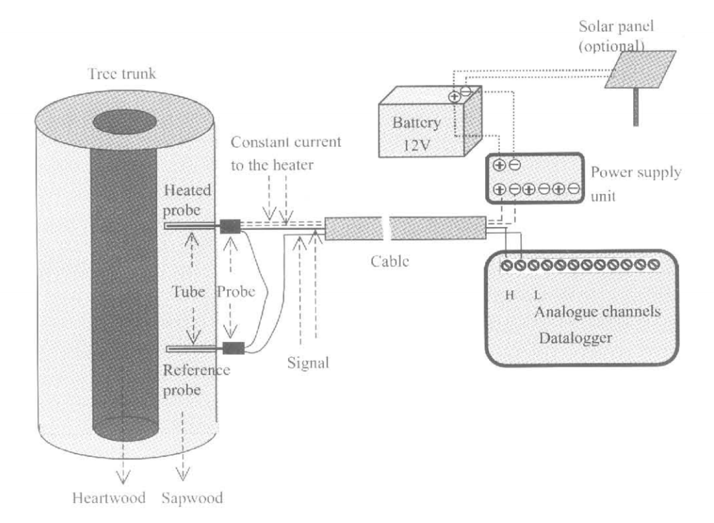
Figure 1. Granier method set-up for measuring sap flux (Lu et al., 2004).

Sap flux data from all plots were collected simultaneously to maximize similarity in humidity, temperature, photosynthetically active radiation, and wind speed. Using the computer software BaseLiner (Duke University), temperature difference was converted into sap flux (g H₂O/m² sap wood /s).
3.3. Diameters at Breast Height and Crown Base
In an attempt to account for some of the tree to tree variability in sap flow, the diameters at breast height (DBH) and at the crown base (D_{CB}) were measured for each instrumented tree. Based on the pipe model theory (Sumida et al., 2013), the cross sectional area of the stem at the base of the live crown (A_{CB}), calculated using D_{CB}, can be used as an index of the amount of leaves on a tree (Sumida et al. 2013). The variation among stem sizes and the amount of leaves from tree to tree was used to try and explain variability in sap flux. A DBH tape was used to measure DBH and a Spiegel relaskop was used to measure D_{CB}.
3.4. Detectable Differences
In order to determine the necessary sample size to detect a minimum significant difference amongst treatments, a power analysis was conducted using Statistical Analysis System (SAS) software (University Edition, SAS Institute Inc., Cary, NC, USA) using the following equation,
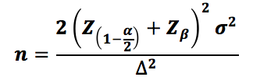
where n is the sample size, Z is a value obtained from a table of probabilities for a specified confidence level, $α$ is the significance level, $β$ is the power level, $σ$ is the coefficient of variance, and $∆$ is the minimum detectable difference.
The coefficient of variance used in the power analysis was calculated using sap flux data from the previous year’s study in 2017 conducted in the MELNHE stand C8 and was determined to be 0.39096. The power level was set at 0.8 and alpha was set at 0.1. By running the analysis using various sample sizes, the minimum detectable difference was determined and compared to detectable differences reported in similar studies.
3.5. Data Analyses
Statistical analysis of the data was conducted using SAS. Graphs were constructed using JMP Pro (Version 14.0.0, SAS Institute Inc., Cary, NC, USA). Daily sums of sap flux were averaged for each tree for days when all probes were functioning properly and under similar weather conditions. A factorial analysis of variance (ANOVA) was conducted to determine statistical significance of sap flux among treatment types (N, P, N+P, and control) and a Tukey test was used to determine differences in sap flux among species (red maple, sugar maple, and white birch). An ANCOVA was used to test significance of sap flux between treatment types (Ca and control) and among species (red maple, sugar maple, and white birch), using DBH as the covariate. A Dunnett’s test was used to test the significance of the treatment effect on sap flux among individual species. A_{CB} was not used in the statistical model as it did not have a strong correlation with sap flux.
4. Results
4.1. Detectable Differences
With four treatment groups (Con, N, P, and NP) and a sample size of nine trees per plot, the minimum detectable difference was calculated to be 57%. A group number of two (Con and Ca) and a sample size of nine gave a minimum detectable difference of 47%. The detectable differences reported in similar studies were determined (Table 1) and used to validate this study’s ability to detect a difference amongst treatments using a sample size of nine.
Study | Objectives | Treatments | Sample Size (n) | Detectable Diff.
Water-use efficiency of tree species following Ca + P application on an abandoned pasture, Central Amazonia, Brazil  (da Silva et al., 2008) | Examine soil moisture and water-use efficiency in secondary growth trees after nutrient additions. | Control,  P (50 kg P₂O₅⁻ /ha),  P + Ca (2 t CaCO₃/ha),  P + Ca + G (1 t CaSO₄/ ha) | 9 trees per treatment  3 trees per species | Photosynthetic rates (A):  +40.5% P to P+Ca  +67.5% Con to P+Ca  +34% P to P+Ca+G  +60% Con to P+Ca+G  Stomatal conductance (g_{s}):  +114% P to P+Ca  +172% Con to P+Ca  +58% P to P+Ca+G  +101% Con to P+Ca+G  Transpiration (E):  +36% P to P+Ca  +59% Con to P+Ca  +21% P to P+Ca+G  +41% Con to P+Ca+G
Effects of nutrient + soil water availability on water use in a Norway spruce stand  (Phillips et al., 2001) | Determine if artificial drought reduces soil water enough to limit whole-tree and plot-scale water transport and to see if fertilization causes an increase in leaf and sapwood areas, thus increasing capacity for water transport. | Control (C),  Drought (D) (65% rain diversion),  Fertilized (F) (47% N, 26% K, 11% P, 6% Ca, 5% Mg, 5% S),  Irrigated and Fertilized (IL) | 10 trees per treatment | Sap flux densities (kg/m2/day):  C= 652a  D=646a  F=449b  Detectable Differences:  C to F= -45%  D to F= -44%
Table 1. Detectable Differences. Similar studies were examined to determine the differences reported amongst treatments using a sample size of n.
4.2. N and P Treatments
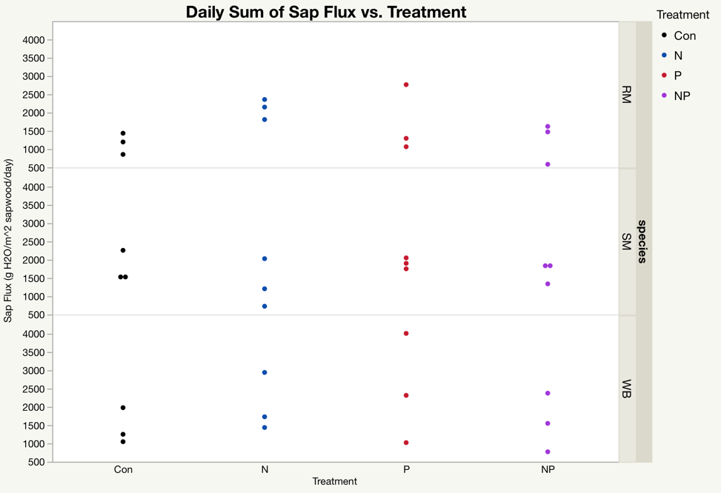
Neither N or P treatments had a significant impact on sap flux (p=0.7526 and p=0.6515, respectively). Additionally, there was no overall detectable interaction between species and treatment (p=0.3369). However, a Tukey test indicated a marginally significant increase in sap flux from control to N for red maples (p=0.1091) and from control to P for white birch (p=0.0836) (Figure 2).
Figure 2. Average daily sum of sap flux (g H₂O/m² sap wood /day) over a 3-day period for species of red maple (RM), sugar maple (SM), and white birch (WB) within treatment plots (Con, N, P, and NP). Each dot represents an individual tree. n=9.
4.3. Calcium Treatment
With DBH and species added to the statistical model, a significant Ca treatment effect was detected (p=0.0571) (Figure 3) along with a marginally significant interaction between treatment and species (p=0.1066) (Figure 4). DBH also exhibited a significant impact on sap flux (p=0.0485). Amongst the three species, red maple exhibited the greatest increase in sap flux with the addition of wollastonite (p=0.0572) (Figure 4).
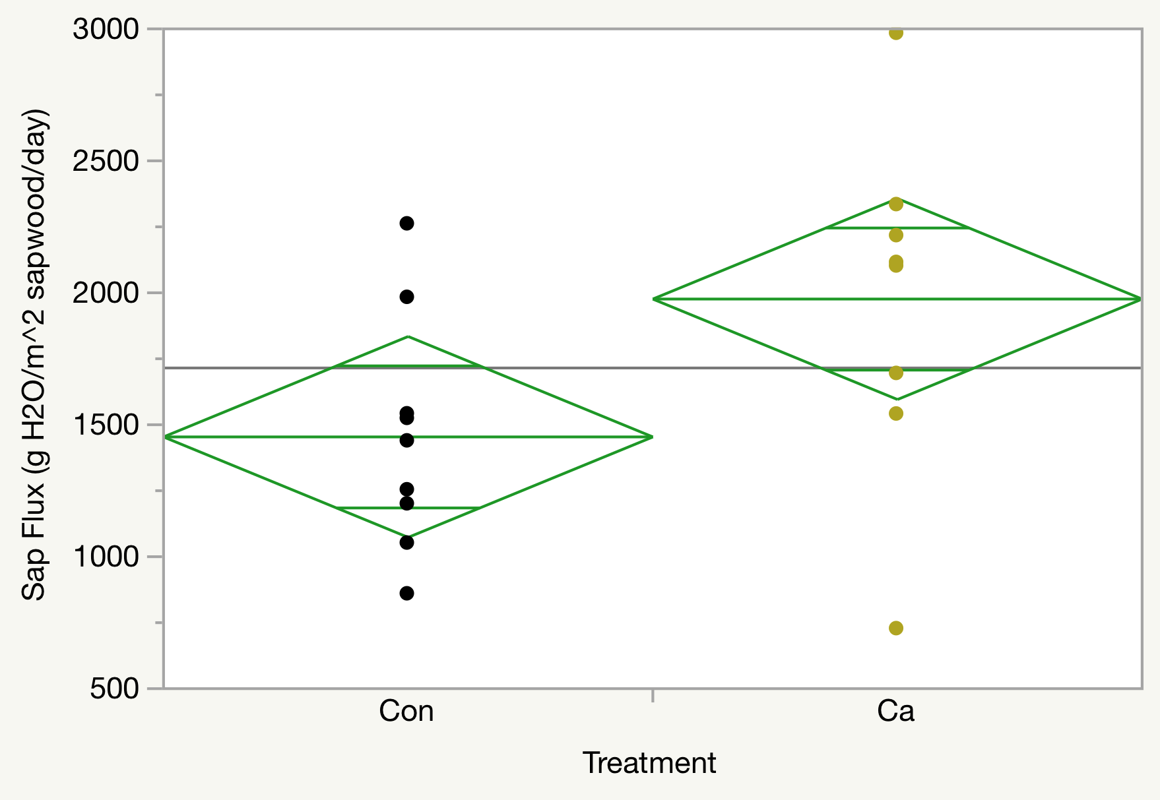
Figure 3. Effects of Calcium on Sap Flux. Average daily sums of sap flux over a 3-day period for all trees in the control and calcium plots. Each dot represents an individual tree. The mean sap flux for trees in the Ca plot are significantly higher than trees in the control (p=0.0571). n=9.

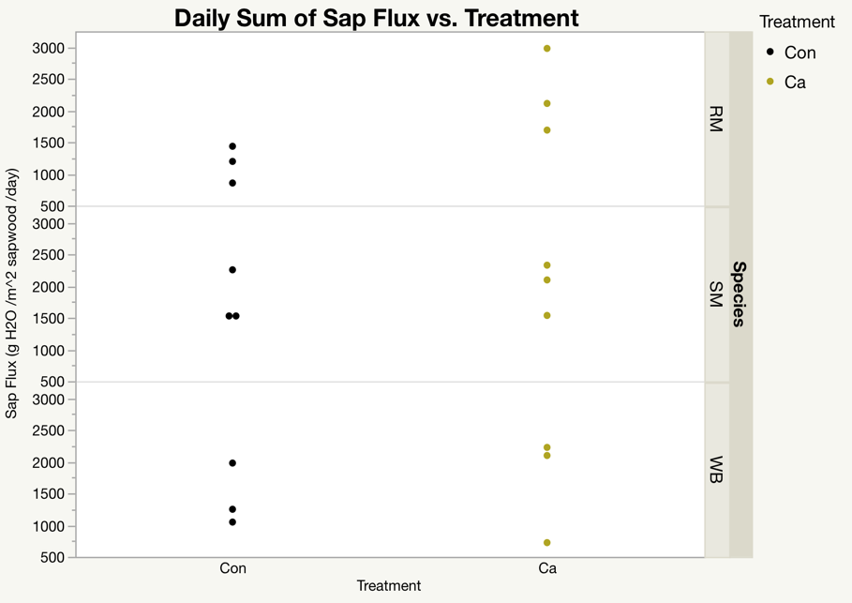
Figure 4. Average daily sum of sap flux (g H₂O/m² sap wood /day) over a 3-day period for species of red maple (RM), sugar maple (SM), and white birch (WB) within treatment plots (Con and Ca). RM (top) exhibits the greatest difference in sap flux from control to Ca (p=0.0572). Each dot represents an individual tree. n=9.
5. Discussion
Nutrients, such as nitrogen, phosphorus, and calcium, are an important component in maintaining plant health. Due to the role that these elements play in many plant physiological and cellular functions, they have the ability to alter tree hydraulic properties and, thus, their water-use as well (da Silva et al., 2008; Green et al., 2013; Phillips et al., 2001). Therefore, it was hypothesized that the additions of nutrients (N, P, and Ca) would results in an increase in water-uptake by the trees, quantified as sap flux. Measurements of sap flux were taken from species of red maple, sugar maple, and white birch and was predicted not to vary much based on species.
The hypothesis that nutrient availability would increase sap flux was not fully supported. There was not a significant treatment effect detected in the N and P treatment plots. Similar results were also obtained from a study conducted within the MELNHE stands in Bartlett, NH which found no impact on sap flux with the addition of nutrients, except for in red maple trees (Hernandez-Santana et al., 2015). While there was no treatment effect detected in the N and P treatment plots, there was a significant increase in sap flux for trees within the Ca plot compared to the control. The treatment effect observed in the Ca plot can help to explain the results from the study done in Hubbard Brook which saw a substantial increase in water-loss from a watershed for three years following the application of wollastonite (Green et al., 2013). Water-loss was measured as the difference between precipitation and run-off and was attributed to an increase in water-uptake by the trees (Green et al., 2013). This conclusion is supported by the results obtained from this study which suggests an increase in sap flux three-years after a one-time wollastonite addition.
Overall, sap flux did not vary greatly from species to species. Analysis of Ca vs. control only exhibited a marginally significant interaction between species and treatment while the NxP factorial indicated no significant interaction. However, consistent with the results reported by Hernandez-Santana et al. (2015), red maple did exhibit stronger treatment effects than the other species in both the N and Ca plots. Sap flux in red maple trees increased with N and Ca additions compared to the control, suggesting that this species may be more sensitive to nutritional status than others.
It is possible that no change in sap flux was detected with N and P additions due to the inherent variability of trees, which could potentially mask any treatment effects. Tree-to-tree variability can be seen in the spread of the data points in Figure 2, where each point represents the average daily sap flux of an individual tree. Within each plot (Con, N, P, NP) trees of the same species do not act similarly as expected, but instead exhibit a wide range of sap flux averages (Figure 2). Tree size, measured by DBH and A_{CB} in this study, were unable to account for the variability in sap flux for trees with N and P additions, while DBH was able to explain variability in sap flux for trees in the Ca and control plots. This could indicate that the variability in the N and P plots is greater than the Ca plot, which may help explain the lack of treatment effect within those plots.
In the future, this study could be improved in many ways. One improvement would be to allow a longer period of time for the nutrients to make an impact. Fertilization of the MELNHE stands only began in 2011; it is possible that it may take longer than seven-years for a treatment effect to become established. Additionally, sap flux data could have a longer collection period. Data was only collected for three days during the summer due to persistent heavy rain-fall. Any following studies should also focus on sap flux in red maple trees, as they appear to be influenced the most by nutrient additions.
6. Conclusion
In conclusion, the addition of Ca in the form of wollastonite (CaSiO₂) resulted in the increase of sap flux. Treatment effects of both Ca and N were more pronounced in red maple trees than other species. As red maple is a dominant species of northern hardwood forests (Goswami et al., 2017), these results have important implications with regards to changing chemical cycles. The northeastern United States is in a state of recovery from acidification, leading to the depletion of base cations, such as Ca, which are used to neutralize strong acid anions (Driscoll et al., 2001). In addition, the northeast has also been subjected to increased N deposition from anthropogenic causes (Goswami et al., 2017). As the cycling of these essential plant nutrients continue to alter, it is important to study how these changes may impact the ability of forests to efficiently utilize their water-budgets.

Acknowledgements
Thank you to my fellow crew members, Chase McPherson, Marissa Gabriel, Donner Riner, and Kate Bazany, and my crew leaders, Alex². This project would not have been possible if it weren’t for their priceless help in both the field and the lab. I would also like to thank my mentors, Alex Rice, Mariann Johnston, and Ruth Yanai for their help and support. Thanks to everyone else on the MELNHE crew!

8. References
Bailey, A., J. W. Hornbeck, C. L. John, and E. Christopher. (2003). Hydrometeorological Database for Hubbard Brook Experimental Forest: 1955 – 2000 The Authors. USDA Northeastern Research Station.

da Silva, C. E. M., Goncalves, J. F. de C., & Feldpausch, T. R. (2008). Water-use efficiency of tree species following calcium and phosphorus application on an abandoned pasture, central Amazonia, Brazil. Environmental and Experimental Botany, 64(2), 189–195.

Driscoll, C.T., Lawrence, G., Bulger, A., Butler, T., Cronan, C., Eagar, C., Lambert, K., Likens, G., Stoddard, J., and Weathers, K. (2001). Acidic Deposition in the Northeastern United States: Sources and Inputs, Ecosystem Effects, and Management Strategies. BioScience, 51(3), 180-198.

Ewers, B. E., D. S. Mackay, J. Tang, P. V. Bolstad, S. Samanta. (2008). Intercomparison of sugar maple (Acer Saccharum Marsh.) stand transpiration responses to environmental conditions from the Western Great Lakes Region of the United States. Agriculture and Forest Meteorology, 148, 231-246.

Ewers, B. E., D. S. Mackay, S.T. Gower, D. E. Ahl, S. N. Burrows, and S. S. Samanta. (2002). Tree species effects on stand transpiration in northern Wisconsin. Water Resources Research, 38(7): 1-11.-

Goswami S, M.C. Fisk, M.A. Vadeboncoeur, M. Johnston, R.D. Yanai, and T.J. Fahey. (2017). Phosphorus limitation of aboveground production in northern hardwood forests. Ecology 99(2): 438-449

Granier, A. (1987). Evaluation of transpiration in a Douglas-fir stand by means of sap flow measurements. Tree Physiology, 3, 309–320.

Green, M. B., Bailey, A. S., Bailey, S. W., Battles, J. J., Campbell, J. L., Driscoll, C. T., … Schaberg, P. G. (2013). Decreased water flowing from a forest amended with calcium silicate. Proceedings of the National Academy of Sciences of the United States of America, 110(15), 5999–6003.

Harrison, S. L. (2015). Increased sap flow in a northern hardwood forest treated with wollastonite (CaSiO₃). Undergraduate Thesis. Ann Arbor, MI: University of Michigan.

Hayhoe, K., Wake, C.P., Huntington, T.G., Luo, L., Schwartz, M.D., Sheffield, J., et al. (2007). Past and future changes in climate and hydrological indicators in the US northeast. Clim. Dyn. 28: 381–407.

Hernandez-Santana, V., Hernandez-Hernandez, A., Vadeboncoeur, M. A., & Asbjornsen, H. (2015). Scaling from single-point sap velocity measurements to stand transpiration in a multispecies deciduous forest: uncertainty sources, stand structure effect, and future scenarios. Canadian Journal of Forest Research, 45(11), 1489–1497.

Lu, P., Urban, L., and Zhao, P. (2004). Granier's thermal dissipation probe (TDP) method for measuring sap flow in trees: Theory and practice. Acta Botanica Sinica, 46(6), 631–646.

Phillips, N., Bergh, J., Oren, R. and Linder, S. (2001) Effects of nutrition and soil water availability on water use in a Norway spruce stand. Tree Physiology, 21, 851-860.

Sumida, A., Miyaura, T. and Torii, H. (2013). Relationships of tree height and diameter at breast height revisited: analyses of stem growth using 20-year data of an even-aged Chamaecyparis obtusa stand. Tree Physiology, 33, 106-118.

Appendix I: First draft of proposal
1. Introduction
Primary productivity of forest ecosystems is limited by the amount of nutrients available for uptake by surrounding vegetation. Limiting resources can be in the form of mineral nutrients such as phosphorus (P), nitrogen (N) and calcium (Ca) or environmental factors such as sunlight and temperature. Studies have suggested that instead of forests being limited by a single nutrient, plants can allocate effort to obtain nutrients such that they may be co-limited by multiple nutrients (Goswami et al., 2017). However, this balance for resource acquisition may take a significant amount of time to become established within an ecosystem and is sensitive to environmental stressors such as climate change and variations within the nutrient cycles (Goswami et al., 2017). As nutrient availability changes due to increased levels of anthropogenic N deposition and the leaching of base cations (Ca²⁺) from the soil due acidification, it has become increasingly more important to understand how nutrient cycling impacts forest ecosystems (Goswami et al., 2017; Green et al., 2013).
To address questions concerning nutrient cycling, the Multiple Element Limitation of Northern Hardwood Ecosystems (MELNHE) study began in 2011 in the White Mountains National Forest, located in New Hampshire, USA. The goal of the MELNHE project is to study how temperate forests acquire and are limited by N and P by conducting nutrient manipulations within stands of varying age. With climate change rapidly altering the environment, knowledge of resource use within forested ecosystems is vital for making inferences about future forest dynamics under variable conditions via predictive models. In addition to studying N and P, the MELNHE project was built upon the Northern Hardwood Forest Calcium Cycling Project and encompass Ca additions at several sites. Within the larger scope of the MELNHE project, this study will focus on one of the mechanisms through which trees obtain and distribute these nutrients: sap flow. Sap flux will be used as a measurement of sap flow scaled to sapwood area, which varies according to species.
In order for plants to produce the ATP necessary for metabolic processes enabling the plant to grow and develop, water is essential (da Silva et al., 2008). The movement of water and nutrients through a tree is called sap flow. Starting with the roots, a mixture of water, nutrients and minerals is absorbed into the xylem through diffusion and continues to travel up the tree, acted on by additional forces of cohesion and adhesion as the tree transpires (Harrison, 2015). Therefore, sap flow can be used to estimate transpiration rates and gives a representation of how forest ecosystems utilize and budget their water use (Hernandez-Santana et al., 2015). Transpiration rates are influenced by environmental conditions such as soil texture and moisture and relative humidity. These rates also vary among species according to their leaf area index (LAI), stem diameter, and age (Ewers et al., 2002; Ewers et al., 2008).
Previous studies have been conducted around the world to examine sap flux in various forest ecosystems. In one study, the effects of nutrient additions of P and Ca on water-use efficiency (WUE) were observed in a six-year old secondary forest in central Amazonia, Brazil. Treatment plots were shown to exhibit lower levels of soil moisture compared to the control, indicating increased WUE with these additions (da Silva et al., 2008). Similar results were also obtained from a study conducted at Hubbard Brook, New Hampshire, USA. The results showed increased annual evapotranspiration rates of 25%, 18%, and 19%, respectively, for three years following the treatment of a wollastonite (CaSiO₃) over an entire watershed (Green et al., 2013). Another study in Bartlett Experimental Forest, New Hampshire, USA examined sap velocity between species to determine how future potential shifts in species composition will alter forest water budgets. This study concluded that transpiration is strongly determined by sapwood area, which depends on both tree species and size (Hernandez-Santana et al., 2015). Despite these findings, little is known about sap flux in temperate forests of the northeastern United States, mainly due to the perceived lack of water stress in the region (Hernandez-Santana et al. 2015). In addition, no studies have been conducted to address how the availability of a limiting nutrient (such as N, P, N+P, or Ca) impact sap flux and if this differs between species.
With the projection that the northeastern United States will experience longer-lasting dry-periods in the coming years due to climate change (Hayhoe et al., 2007), it is becoming increasingly crucial to study water cycling in temperate forests and what influences this process. This study aims to identify how the availability of nutrients, specifically N, P, N+P, and Ca, will impact sap flux and to observe specific variations in response among species of red maple, sugar maple, and white birch.
2. Objectives
The objective of this study is to determine the influence of nutrients, including N, P, N+P, and Ca, on sap flux in trees. We will compare sap flux between species of red maple, sugar maple, and white birch. Sap flux data from the three species will be used to estimate the influence of nutrients on sap flux at the plot-scale. Based on the theory of co-limitation, I hypothesize that the trees fertilized with N+P will exhibit the highest rates of sap flux compared to N or P alone. I also expect to see trees fertilized with Ca to have higher rates of sap flux than those without Ca additions.
3. Methods
3.1. Site Description
I will conduct this study in the Hubbard Brook Experimental Forest (HBEF) in the White Mountain National Forest, New Hampshire, USA. The soils at these sites are Typic and Aquic Haplorthods which were formed by glacial drift about 14,000 ago (Bailey et al., 2003). The region experiences cold winters with an average temperature in January of -9 °C and warm summers with an average July temperature of 19 °C (Bailey et al., 2003). The region receives an average yearly precipitation of 140 cm, evenly distributed throughout the year (Bailey et al., 2003).
This study will collect data from a site established by the MELNHE project, referred to as stand HB mid. Stand HB mid is a middle-aged stand which was last clearcut in 1970. The area is composed mainly of red maple (Acer rubrum L.), sugar maple (Acer saccharum Marsh.), American beech (Fagus grandifolia Ehrh.), yellow birch (Betula alleghniensis Britton.), and white birch (Betula papyrifera Marsh.). The stands include five plots fertilized with either N, P, N+P, Ca, and the control. Data will be collected from N, P, N+P, Ca and control plots in HB mid (5 plots total). Each plot is marked by an area of 30 meter by 30 meter, which contains a 20 meter by 20 meter inner area and a 10 meter surrounding buffer. Since 2011, the MELNHE project has fertilized each plot with either 30 kg N ha⁻¹ yr⁻¹ (NH₄NO₃), 10 kg P ha⁻¹ yr⁻¹ (NaH₂PO₄), a mixture of both amounts of N and P, or nothing for the control. The HB mid Ca plot was fertilized once with 1150 kg Ca ha⁻¹ in the form of wollastonite (CaSiO₂) in 2015.
3.2. Sap Flux Measurements
Sap flux of red maple (Acer rubrum L.), sugar maple (Acer saccharum Marsh.), and white birch (Betula papyrifera Marsh.) in stand HB mid will be determined using the Granier method, otherwise known as the thermal dissipation probe (TDP) method (Granier, 1987). The Granier method functions by measuring the temperature difference (°C) between two sensor probes installed into the sapwood of a tree and converting it into sap flux units (Figure 1). Sap flux will be measured for three trees of each species per plot, forty-five trees total for the stand. Probes will be assembled in the lab according to the Granier Sap Flow Sensor Protocol prior to entering the field. Before installing the sensors into the trees, a small patch of bark will be removed at breast height (1.4 m from the ground) on the south-facing side of the tree using a chisel and another patch will be removed 10 cm above. The heater probe will be placed in the patch above the reference probe into 2.8 mm diameter holes drilled 21mm into the sapwood. Sensors will be wired to a data logger and a twelve-volt marine battery (Figure 1). The batteries will power the data loggers and supply the heater probe with a constant current (Granier, 1987).
Figure 1. Granier method set-up for measuring sap flow (Lu et al., 2004).

Sap flowing through the xylem will exert a temperature change in the heated probe relative to the reference which will induce a detectable change in voltage between thermocouples (a sensor used to measure temperature) within the probes (Granier, 1987). Temperature difference between the two thermocouples will be recorded with the data loggers every 30 seconds and an average will be calculated for every 15 minutes.
A nearby NEON weather sensor will be used to collect data on various weather conditions which impact sap flux rates, including humidity, temperature, photosynthetically active radiation (PAR), and wind speed. Data from all plots within the stand will be collected under similar weather conditions in order to reduce variables. Data will be recorded for three to four days at each stand.
3.3. Diameter at Crown Base
To account for tree to tree variability, the diameter at the crown base (D_{CB}) (cm²) will be measured for each instrumented tree. Based on the pipe model theory, the cross sectional area of the stem at the base of the live crown (A_{CB}) (cm²), calculated using the equation A_{CB}=D_{CB}² π/4, is directly proportional to the amount of leaves on a tree (Sumida et al. 2013). The differences between the amount of leaves from tree to tree could help explain variability in sap flux. A relaskop will be used to measure D_{CB}.
3.4. Data Analyses
Temperature difference will be converted into sap flux (g H₂O/m² sap wood /s) using the computer software BaseLiner.
Statistical analysis of the data will be conducted using Statistical Analysis System (SAS) software (University Edition, SAS Institute, Cary, NC, USA). Daily sums of sap flux will be averaged for days when all probes were functioning properly. A factorial analysis of variance (ANOVA) will be conducted to determine statistical significance of sap flux between treatment types (N, P, N+P, and control) and between species (red maple, sugar maple, and white birch). A one-way ANOVA will be used to test significance of sap flux between treatment types (Ca and control) and between species (red maple, sugar maple, and white birch). Significance level will be set at p < 0.1.
The correlation between sap flux and D_{CB} will be plotted with D_{CB} as the independent variable and sap flux as the dependent variable. If a correlation between the two measurements is detected, D_{CB} will be added to the statistical model.
4. Potential Pitfalls and Plans for Remediation
- Not enough data loggers.
  - Remediation: Collect data from one site at a time. Make sure that the days when data is collected have similar weather conditions.
- Trees too spread out, won’t be able to collect sap flux data for 3 trees per species per plot.
  - Remediation: Look at species composition maps ahead of time.
- Sap flux measurement system failing.
  - Remediation: Test runs, consulting sap flow protocol.
- Carrying heavy batteries into HB mid plots (too far to walk them).
  - Remediation: Get ATV or get lots of people to help carry batteries. Use frame packs to carry batteries.
5. Expected Results
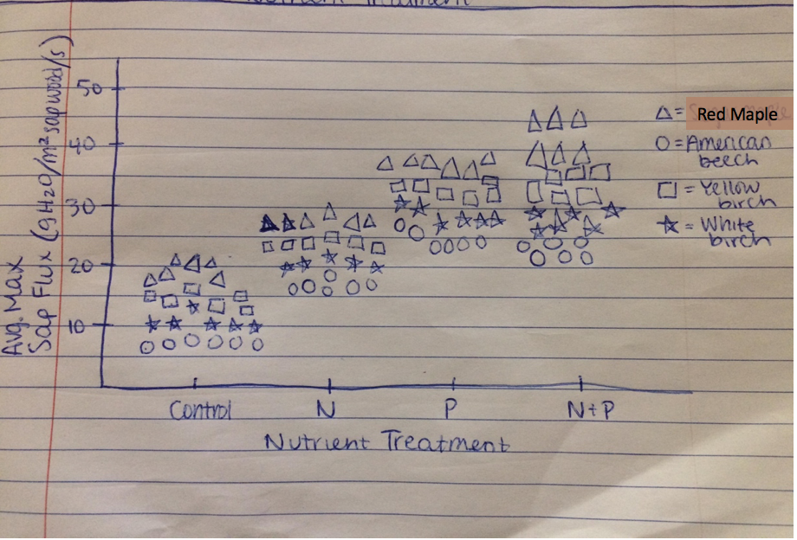
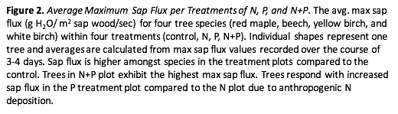

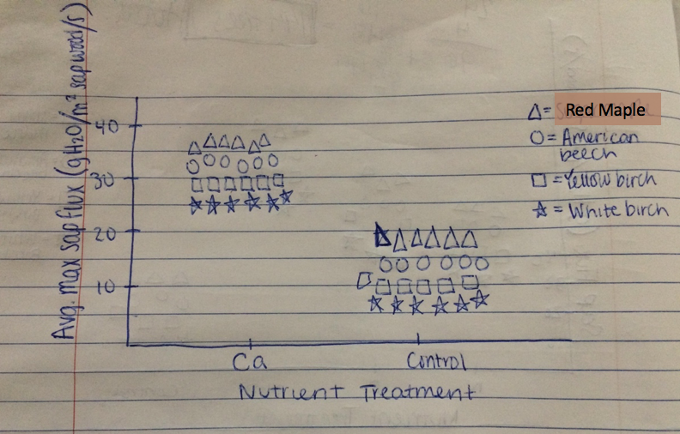
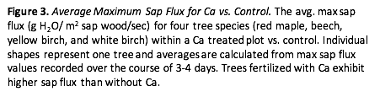

6. Timeline
Week of June 11-15:
1st draft of proposal due, peer review, learn how to build probes!!!
Final draft of proposal due, conference call with Ruth
Finish charging batteries
Build probes
Week of June 18-22:
Build probes and attach to gray wire
Trial-run on a nearby tree
Week of June 25-29:
Revise proposal
Week of July 2-6:
Revise proposal
Work on HB presentation
Week of July 9-13:
Attach probes to gray wires
HB meeting
Bring batteries to HB on Friday
Week of July 16-20:
Instrument trees at HB
Data collection (3-4 days)
Week of July 23-27:
Collect data from loggers
Data analysis
Week of July 30-August 3:
Update proposal
Week of August 6-10:
Clean-up and upload data to MELNHE site
7. Materials and Supplies
- 110-120 Probes (list of materials needed for construction and sensor installation are in Granier Sap Flow Sensor Protocol, pages 1 and 10)
- 5 data loggers
- BaseLiner software
- SAS software
- Field notebook
- 12V marine batteries (15 total, 3 per plot)
- Electric Drill (with bits of varying sizes listed in probe protocol)
- Staple gun
- Ruler (cm)
- Measuring tape
- Electric rotary dremel tool
- Electric soldering iron and butane-powered soldering iron
- Multimeter
- Wire clippers
- Small chisel
- Razor blade
- Small screwdriver
- Wire stripper
- Caulk gun
- Lighter
- Pliers
- Trash bags
- Relaskop
- People to help with probe building and installation

8. References
Bailey, A., J. W. Hornbeck, C. L. John, and E. Christopher. (2003). Hydrometeorological Database for Hubbard Brook Experimental Forest: 1955 – 2000 The Authors. USDA Northeastern Research Station.

da Silva, C. E. M., Goncalves, J. F. de C., & Feldpausch, T. R. (2008). Water-use efficiency of tree species following calcium and phosphorus application on an abandoned pasture, central Amazonia, Brazil. Environmental and Experimental Botany, 64(2), 189–195.

Ewers, B. E., D. S. Mackay, J. Tang, P. V. Bolstad, S. Samanta. (2008). Intercomparison of sugar maple (Acer Saccharum Marsh.) stand transpiration responses to environmental conditions from the Western Great Lakes Region of the United States. Agriculture and Forest Meteorology, 148, 231-246.

Ewers, B. E., D. S. Mackay, S.T. Gower, D. E. Ahl, S. N. Burrows, and S. S. Samanta. (2002). Tree species effects on stand transpiration in northern Wisconsin. Water Resources Research, 38(7): 1-11.

Goswami S, M.C. Fisk, M.A. Vadeboncoeur, M. Johnston, R.D. Yanai, and T.J. Fahey. (2017). Phosphorus limitation of aboveground production in northern hardwood forests. Ecology 99(2): 438-449

Granier, A. (1987). Evaluation of transpiration in a Douglas-fir stand by means of sap flow measurements. Tree Physiology, 3, 309–320.

Green, M. B., Bailey, A. S., Bailey, S. W., Battles, J. J., Campbell, J. L., Driscoll, C. T., … Schaberg, P. G. (2013). Decreased water flowing from a forest amended with calcium silicate. Proceedings of the National Academy of Sciences of the United States of America, 110(15), 5999–6003.

Harrison, S. L. (2015). Increased sap flow in a northern hardwood forest treated with wollastonite (CaSiO₃). Undergraduate Thesis. Ann Arbor, MI: University of Michigan.

Hayhoe, K., Wake, C.P., Huntington, T.G., Luo, L., Schwartz, M.D., Sheffield, J., et al. (2007). Past and future changes in climate and hydrological indicators in the US northeast. Clim. Dyn. 28: 381–407.

Hernandez-Santana, V., Hernandez-Hernandez, A., Vadeboncoeur, M. A., & Asbjornsen, H. (2015). Scaling from single-point sap velocity measurements to stand transpiration in a multispecies deciduous forest: uncertainty sources, stand structure effect, and future scenarios. Canadian Journal of Forest Research, 45(11), 1489–1497.

Lu, P., Urban, L., and Zhao, P. (2004). Granier's thermal dissipation probe (TDP) method for measuring sap flow in trees: Theory and practice. Acta Botanica Sinica, 46(6), 631–646.

Sumida, A., Miyaura, T. and Torii, H. (2013). Relationships of tree height and diameter at breast height revisited: analyses of stem growth using 20-year data of an even-aged Chamaecyparis obtusa stand. Tree Physiology, 33, 106-118.

Appendix II: second draft of proposal with Ruth’s and Mariann’s comments
1. Introduction
Primary productivity of forest ecosystems is limited by the amount of nutrients available for uptake by surrounding vegetation. Limiting resources can be in the form of mineral nutrients such as phosphorus (P), nitrogen (N) and calcium (Ca) or environmental factors such as sunlight and temperature. Studies have suggested that instead of forests being limited by a single nutrient, plants can allocate effort to obtain nutrients such that they may be co-limited by multiple nutrients (Goswami et al., 2017). However, this balance for resource acquisition may take a significant amount of time to become established within an ecosystem and is sensitive to environmental stressors such as climate change and variations within the nutrient cycles (Goswami et al., 2017). As nutrient availability changes due to increased levels of anthropogenic N deposition and the leaching of base cations (Ca²⁺) from the soil due acidification, it has become increasingly more important to understand how nutrient cycling impacts forest ecosystems (Goswami et al., 2017; Green et al., 2013).
To address questions concerning nutrient cycling, the Multiple Element Limitation of Northern Hardwood Ecosystems (MELNHE) study began in 2011 in the White Mountains National Forest, located in New Hampshire, USA. The goal of the MELNHE project is to study how temperate forests acquire and are limited by N and P by conducting nutrient manipulations within stands of varying age. With climate change rapidly altering the environment, knowledge of resource use within forested ecosystems is vital for making inferences about future forest dynamics under variable conditions via predictive models. In addition to studying N and P, the MELNHE project was built upon the Northern Hardwood Forest Calcium Cycling Project and encompass Ca additions at several sites. Within the larger scope of the MELNHE project, this study will focus on one of the mechanisms through which trees obtain and distribute these nutrients: sap flow. Sap flux will be used as a measurement of sap flow scaled to sapwood area, which varies according to species.
In order for plants to produce the ATP necessary for metabolic processes enabling the plant to grow and develop, water is essential (da Silva et al., 2008). The movement of water and nutrients through a tree is called sap flow. Starting with the roots, a mixture of water, nutrients and minerals is absorbed into the xylem through diffusion and continues to travel up the tree, acted on by additional forces of cohesion and adhesion as the tree transpires (Harrison, 2015). Therefore, sap flow can be used to estimate transpiration rates and gives a representation of how forest ecosystems utilize and budget their water use (Hernandez-Santana et al., 2015). Transpiration rates are influenced by environmental conditions such as soil texture and moisture and relative humidity. These rates also vary among species according to their leaf area index (LAI), stem diameter, and age (Ewers et al., 2002; Ewers et al., 2008).
Previous studies have been conducted around the world to examine sap flux in various forest ecosystems. In one study, the effects of nutrient additions of P and Ca on water-use efficiency (WUE) were observed in a six-year old secondary forest in central Amazonia, Brazil. Treatment plots were shown to exhibit lower levels of soil moisture compared to the control, indicating increased WUE with these additions (da Silva et al., 2008). Similar results were obtained from a study conducted at Hubbard Brook, New Hampshire, USA. The results showed increased annual evapotranspiration rates of 25%, 18%, and 19%, respectively, for three years following application of wollastonite (CaSiO₃) over a small watershed (Green et al., 2013). Another study in Bartlett Experimental Forest, New Hampshire, USA examined sap velocity between species to determine how future potential shifts in species composition will alter forest water budgets. This study concluded that transpiration is strongly determined by sapwood area, which depends on both tree species and size (Hernandez-Santana et al., 2015). Despite these findings, little is known about sap flux in temperate forests of the northeastern United States, mainly due to the perceived lack of water stress in the region (Hernandez-Santana et al. 2015). In addition, no studies have been conducted to address how the availability of a limiting nutrient (such as N, P, N+P, or Ca) impact sap flux and if this differs between species.
With the projection that the northeastern United States will experience longer-lasting dry-periods in the coming years due to climate change (Hayhoe et al., 2007), it is becoming increasingly crucial to study water cycling in temperate forests and what influences this process. This study aims to identify how the availability of nutrients, specifically N, P, N+P, and Ca, will impact sap flux and to observe specific variations in response among species of red maple, sugar maple, and white birch.
2. Objectives
The objective of this study is to determine the influence of nutrients, namely N, P, N+P, and Ca, on sap flux in trees. We will compare sap flux among species of red maple, sugar maple, and white birch. Sap flux data from the three species will be used to estimate the influence of nutrients on sap flux at the plot-scale. Based on the theory of co-limitation, I hypothesize that the trees fertilized with N+P will exhibit the highest rates of sap flux compared to N or P alone. I also expect to see trees fertilized with Ca to have higher rates of sap flux than those without Ca additions.
3. Methods
3.1. Site Description
I will conduct this study in the Hubbard Brook Experimental Forest (HBEF) in the White Mountain National Forest, New Hampshire, USA. The soils at these sites are Typic and Aquic Haplorthods formed in glacial drift about 14,000 ago (Bailey et al., 2003). The region experiences cold winters with an average temperature in January of -9 °C and warm summers with an average July temperature of 19 °C (Bailey et al., 2003). The region receives an average yearly precipitation of 140 cm, evenly distributed throughout the year (Bailey et al., 2003).
We will collect data from a site established by the MELNHE project, referred to as stand HB mid. Stand HB mid is a middle-aged stand which was last clearcut in 1970. The forest is composed mainly of red maple (Acer rubrum L.), sugar maple (Acer saccharum Marsh.), American beech (Fagus grandifolia Ehrh.), yellow birch (Betula alleghniensis Britton.), and white birch (Betula papyrifera Marsh.). The stands include five plots fertilized with either N, P, N+P, Ca, and the control. Data will be collected from N, P, N+P, Ca and control plots in HB mid (5 plots total). Each plot is marked by an area of 30 meter by 30 meter, which contains a 20 meter by 20 meter inner area and a 10 meter surrounding buffer. Since 2011, the MELNHE project has fertilized each plot with either 30 kg N ha⁻¹ yr⁻¹ (NH₄NO₃), 10 kg P ha⁻¹ yr⁻¹ (NaH₂PO₄), a mixture of both amounts of N and P, or nothing for the control. The HB mid Ca plot was fertilized once with 1150 kg Ca ha⁻¹ in the form of wollastonite (CaSiO₂) in 2015.
3.2. Sap Flux Measurements
Sap flux of red maple (Acer rubrum L.), sugar maple (Acer saccharum Marsh.), and white birch (Betula papyrifera Marsh.) will be determined using the thermal dissipation probe (TDP) method (Granier, 1987). The Granier method involves measuring the temperature difference (°C) between two sensor probes installed into the sapwood of a tree and converting it into sap flux units (Figure 1). Sap flux will be measured for three trees of each species per plot, for a total of 45 trees. Probes will be assembled in the lab according to the Granier Sap Flow Sensor Protocol prior to entering the field. Before installing the sensors into the trees, a small patch of bark will be removed at breast height (1.4 m from the ground) on the south-facing side of the tree using a chisel and another patch will be removed 10 cm above. The heater probe will be placed in the patch above the reference probe into 2.8 mm diameter holes drilled 21mm into the sapwood. Sensors will be wired to a data logger and a twelve-volt marine battery (Figure 1). The batteries will power the data loggers and supply the heater probe with a constant current (Granier, 1987).
Figure 1. Granier method set-up for measuring sap flow (Lu et al., 2004).

Sap flowing through the xylem will exert a temperature change in the heated probe relative to the reference which will induce a detectable change in voltage between thermocouples (a sensor used to measure temperature) within the probes (Granier, 1987). The temperature difference between the two thermocouples will be recorded with the data loggers every 30 seconds and an average will be calculated for every 15 minutes.
A nearby NEON weather sensor will be used to collect data on various weather conditions which impact sap flux rates, including. Data from all plots within the stand will be collected simultaneously to maximize similarity in humidity, temperature, photosynthetically active radiation (PAR), and wind speed.
3.3. Diameter at Crown Base
In an attempt to account for some of the tree-to-tree variability in sap flow, the diameter at the crown base (D_{CB}) (cm²) will be measured for each instrumented tree. Based on the pipe model theory (reference), the cross sectional area of the stem at the base of the live crown (A_{CB}) (cm²), calculated using the equation A_{CB}=D_{CB}² π/4, is proportional to the amount of leaves on a tree (Sumida et al. 2013). The differences between the amount of leaves from tree to tree could help explain variability in sap flux. A relaskop will be used to measure D_{CB}.
3.4. Data Analyses
Temperature difference will be converted into sap flux (g H₂O/m² sap wood /s) using the computer software BaseLiner.
Statistical analysis of the data will be conducted using Statistical Analysis System (SAS) software (University Edition, SAS Institute, Cary, NC, USA). Daily sums of sap flux will be averaged for days when all probes were functioning properly. A factorial analysis of variance (ANOVA) will be conducted to determine statistical significance of sap flux between treatment types (N, P, N+P, and control) and between species (red maple, sugar maple, and white birch). A one-way ANOVA will be used to test significance of sap flux between treatment types (Ca and control) and between species (red maple, sugar maple, and white birch). Significance level will be set at p < 0.1.
The correlation between sap flux and D_{CB} will be plotted with D_{CB} as the independent variable and sap flux as the dependent variable. If a correlation between the two measurements is detected, D_{CB} will be added to the statistical model.
4. Potential Pitfalls and Plans for Remediation
- Not enough data loggers.
  - Remediation: Collect data from one site at a time. Make sure that the days when data is collected have similar weather conditions.
- Trees too spread out, won’t be able to collect sap flux data for 3 trees per species per plot.
  - Remediation: Look at species composition maps ahead of time.
- Sap flux measurement system failing.
  - Remediation: Test runs, consulting sap flow protocol.
- Carrying heavy batteries into HB mid plots (too far to walk them).
  - Remediation: Get ATV or get lots of people to help carry batteries. Use frame packs to carry batteries.
5. Expected Results

6. Timeline
Week of June 11-15:
1st draft of proposal due, peer review, learn how to build probes!!!
Final draft of proposal due, conference call with Ruth
Finish charging batteries
Build probes
Week of June 18-22:
Build probes and attach to gray wire
Trial-run on a nearby tree
Week of June 25-29:
Revise proposal
Week of July 2-6:
Revise proposal
Work on HB presentation
Week of July 9-13:
Attach probes to gray wires
HB meeting
Bring batteries to HB on Friday
Week of July 16-20:
Instrument trees at HB
Data collection (3-4 days)
Week of July 23-27:
Collect data from loggers
Data analysis
Week of July 30-August 3:
Update proposal
Week of August 6-10:
Clean-up and upload data to MELNHE site
7. Materials and Supplies
- 110-120 Probes (list of materials needed for construction and sensor installation are in Granier Sap Flow Sensor Protocol, pages 1 and 10)
- 5 data loggers
- BaseLiner software
- SAS software
- Field notebook
- 12V marine batteries (15 total, 3 per plot)
- Electric Drill (with bits of varying sizes listed in probe protocol)
- Staple gun
- Ruler (cm)
- Measuring tape
- Electric rotary dremel tool
- Electric soldering iron and butane-powered soldering iron
- Multimeter
- Wire clippers
- Small chisel
- Razor blade
- Small screwdriver
- Wire stripper
- Caulk gun
- Lighter
- Pliers
- Trash bags
- Relaskop
- People to help with probe building and installation

8. References
Bailey, A., J. W. Hornbeck, C. L. John, and E. Christopher. (2003). Hydrometeorological Database for Hubbard Brook Experimental Forest: 1955 – 2000 The Authors. USDA Northeastern Research Station.

da Silva, C. E. M., Goncalves, J. F. de C., & Feldpausch, T. R. (2008). Water-use efficiency of tree species following calcium and phosphorus application on an abandoned pasture, central Amazonia, Brazil. Environmental and Experimental Botany, 64(2), 189–195.

Ewers, B. E., D. S. Mackay, J. Tang, P. V. Bolstad, S. Samanta. (2008). Intercomparison of sugar maple (Acer Saccharum Marsh.) stand transpiration responses to environmental conditions from the Western Great Lakes Region of the United States. Agriculture and Forest Meteorology, 148, 231-246.

Ewers, B. E., D. S. Mackay, S.T. Gower, D. E. Ahl, S. N. Burrows, and S. S. Samanta. (2002). Tree species effects on stand transpiration in northern Wisconsin. Water Resources Research, 38(7): 1-11.

Goswami S, M.C. Fisk, M.A. Vadeboncoeur, M. Johnston, R.D. Yanai, and T.J. Fahey. (2017). Phosphorus limitation of aboveground production in northern hardwood forests. Ecology 99(2): 438-449

Granier, A. (1987). Evaluation of transpiration in a Douglas-fir stand by means of sap flow measurements. Tree Physiology, 3, 309–320.

Green, M. B., Bailey, A. S., Bailey, S. W., Battles, J. J., Campbell, J. L., Driscoll, C. T., … Schaberg, P. G. (2013). Decreased water flowing from a forest amended with calcium silicate. Proceedings of the National Academy of Sciences of the United States of America, 110(15), 5999–6003.

Harrison, S. L. (2015). Increased sap flow in a northern hardwood forest treated with wollastonite (CaSiO₃). Undergraduate Thesis. Ann Arbor, MI: University of Michigan.

Hayhoe, K., Wake, C.P., Huntington, T.G., Luo, L., Schwartz, M.D., Sheffield, J., et al. (2007). Past and future changes in climate and hydrological indicators in the US northeast. Clim. Dyn. 28: 381–407.

Hernandez-Santana, V., Hernandez-Hernandez, A., Vadeboncoeur, M. A., & Asbjornsen, H. (2015). Scaling from single-point sap velocity measurements to stand transpiration in a multispecies deciduous forest: uncertainty sources, stand structure effect, and future scenarios. Canadian Journal of Forest Research, 45(11), 1489–1497.

Lu, P., Urban, L., and Zhao, P. (2004). Granier's thermal dissipation probe (TDP) method for measuring sap flow in trees: Theory and practice. Acta Botanica Sinica, 46(6), 631–646.

Sumida, A., Miyaura, T. and Torii, H. (2013). Relationships of tree height and diameter at breast height revisited: analyses of stem growth using 20-year data of an even-aged Chamaecyparis obtusa stand. Tree Physiology, 33, 106-118.

