Sunday August 16, 2009
9:00 Families Arrive and Check In
Nifkin Lounge, Marshall Hall
Move into Watson Hall

12:00 Lunch and Welcome Orientation
Dean Cynthia Sedgwick, Dr. Raydora
Drummer Francis - Nifkin Lounge

6:00 Dinner in Shaw Hall

7:30 Getting to Know You - Nifkin Lounge

8:30 Movie and Fun Time - Nifkin Lounge

Monday August 17, 2009
7:30 Breakfast - Shaw Hall

8:30 Biology Seminar, Dr. Melissa Fierke
Moon 110

10:30 ESF 101, Dean Cynthia Sedgwick & Dr. Don Leopold – Moon 110

12:00 Lunch - Shaw Hall

1:30 Writing for an Audience Part I
Professor Dawnelle Jager – Moon
110

2:45 Beyond the Books: Student Life at ESF, Ms. Leah Flynn & Ms. Liz Mix – Moon 110

4:00 Break/Dinner - Shaw Hall

6:30 Study Hall - Nifkin Lounge

7:30 Bowling, Strike-N-Spare Lanes

Tuesday August 18, 2009
7:30 Breakfast - Shaw Hall

8:30 Biology Seminar – Moon 110

10:30 Discovering Your Personality Ms. Heather Rice – Moon 110

11:15 ESF 101

12:00 Lunch - Shaw Hall

1:30 Aquatic Inverts, Dr. Neil Ringler Chittenango Creek, Cazenovia

4:00 Ice Cream - Cazenovia

6:00 Dinner in Shaw Hall

Wednesday August 19, 2009
7:30 Breakfast - Shaw Hall

8:30 Biology Seminar – Moon 110

10:30 Managing Your Money, Ms. Schaelon Davis – Moon 110

11:15 ESF 101

12:00 Lunch - Shaw Hall

1:30 Introduction to Chemistry, Dr. Neal Abrams – Moon 19

2:30 Finding Your Place in the Field – Academic Success at ESF, Mr. Scott Blair – Academic Success Center, Moon 19

3:15 Are You E-Literate? Computer Services, Mr. Chris Pedley -309 Baker Hall

4:15 Break/Dinner - Shaw Hall

6:30 Study Hall - Nifkin Lounge

7:30 Like It Is: Student Panel - Nifkin Lounge

Thursday August 20, 2009
7:30 Breakfast - Shaw Hall

8:30 Biology Seminar – Moon 110

10:30 Writing for an Audience Part II
Professor Jager – Moon 110

12:00 Lunch – Shaw Hall

1:30 ESF 101

3:00 Moon Library Walk and Talk,
Peer Advisor Brittany Meeks - Moon
Library

4:00 Discovering Your Personality II
Ms. Heather Rice – 145 Baker Hall

5:00 Dinner - Shaw Hall

6:30 Carousel Shopping Mall - Syracuse

Friday August 21, 2009
7:30 Breakfast - Shaw Hall

8:30 MOVING DAY - Move Out of Watson Hall to Permanent Fall Housing

12:00 Lunch - Shaw Hall

1:30 ESF 101

2:15 Inspirational Insights, Dr. Charles Hall & Dr. Raymond Francis – 145 Baker Hall

3:00 What Kind of Leader are You, Dr. Raydora Drummer Francis
The CSTEP Program, Ms. Eileen Baldassarre – 145 Baker Hall

5:00 Dinner - Shaw Hall

Saturday August 22, 2009
8:45 Shuttle Bus from South Campus

9:00 Breakfast - Shaw Hall
Make Sack Lunch & Dinner for Trip

10:00 Fun Day at Darien Lake Theme Park
Arrive at 1:00 pm. Leave 8:00 pm.

Sunday August 23, 2009
Free Day to Rest and Relax

11:00 Shuttle to Shaw Hall for Brunch

Monday August 24, 2009
7:30 Breakfast - Shaw Hall

8:30 Biology Seminar Lab, Mr. Warren Hellman - Moon 110

12:00 Lunch - Shaw Hall

1:00 Multicultural Resources at ESF & SU, Student Leaders – Moon 110

2:00 ESF 101

5:00 Dinner – Shaw Hall

Tuesday August 25, 2009
7:30 Breakfast - Shaw Hall

8:30 Biology Seminar, Moon 110

10:00 ESF 101 Presentations – Moon 110

12:00 Lunch - Shaw Hall

2:00 ESF’s Willow Project, Dr. Abrahamson & ESF’s Heiberg Forest, Dr. Guy Baldassarre - Tully

6:30 Cook-Out & Games at Baldassarre’s House - Tully

Wednesday August 26, 2009
7:30 Breakfast - Shaw Hall

9:00 Wrap-Up Business - 321 Bray Hall

9:30 Closing Ceremony/ Evaluation
321 Bray Hall

11:00 Join the ESF Orientation
MANDATORY PARTICIPATION

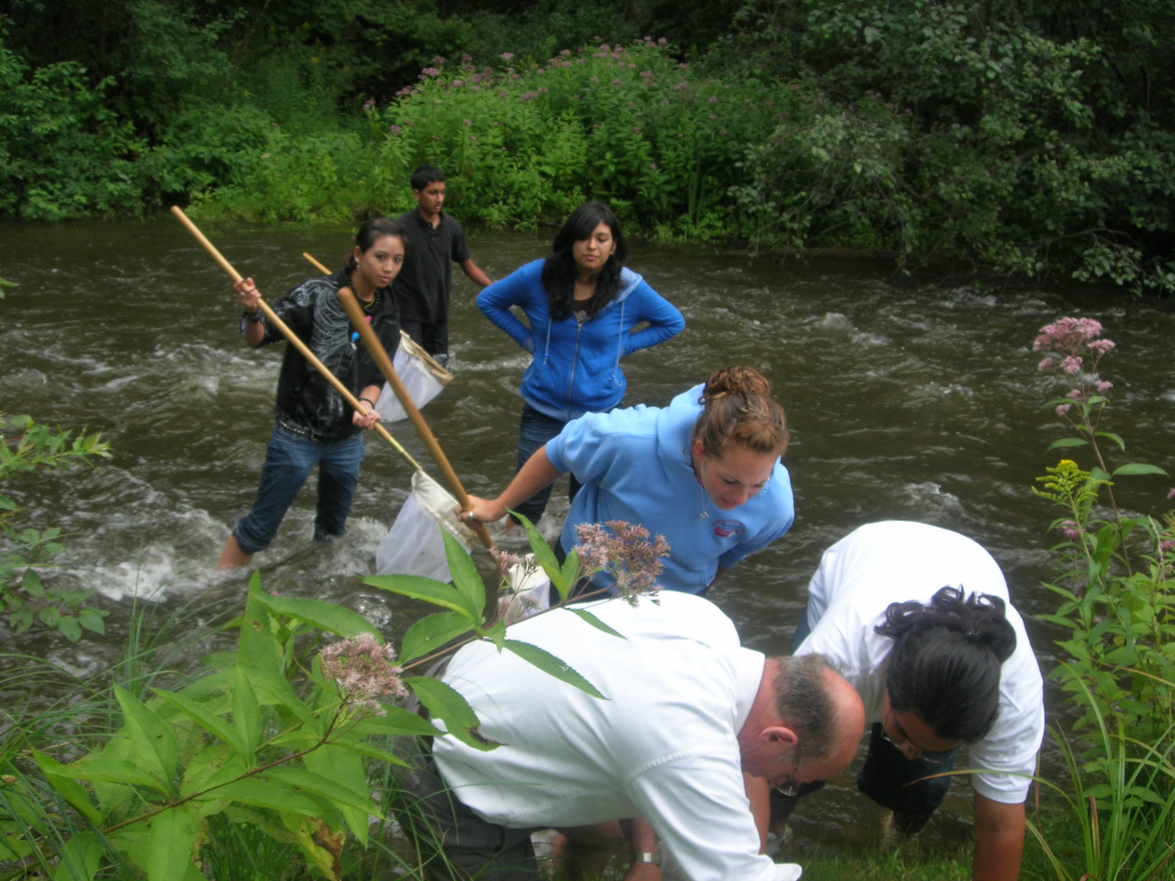


DIRECTORY

Dr. Lawrence Abrahamson, Environmental and Forest Biology
126 Illick Hall, 470-6777

Dr. Neal Abrams, Chemistry
422 Jahn Laboratory, 470-4723

Ms. Eileen Baldassarre, CSTEP Administrative Coordinator
43 Bray Hall, 470-4895

Dr. Guy Baldassarre, Environmental and Forest Biology
207 Illick Hall, 470-6739

Mr. Scott Blair, Academic Success Center
Moon Library, 470-4921

Ms. Schaelon Davis, Assistant Director, Financial Aid
113 Bray Hall, 470-6672

Dr. Raydora Drummer Francis, Director- Multicultural Affairs
43 Bray Hall, 470-4815

Dr. Melissa Fierke, Environmental and Forest Biology
146 Illick Hall, 470-6809

Ms. Leah Flynn, Assistant Director, Student Activities
110 Bray Hall, 470-6658

Dr. Raymond Francis, Paper and Bioprocess Engineering
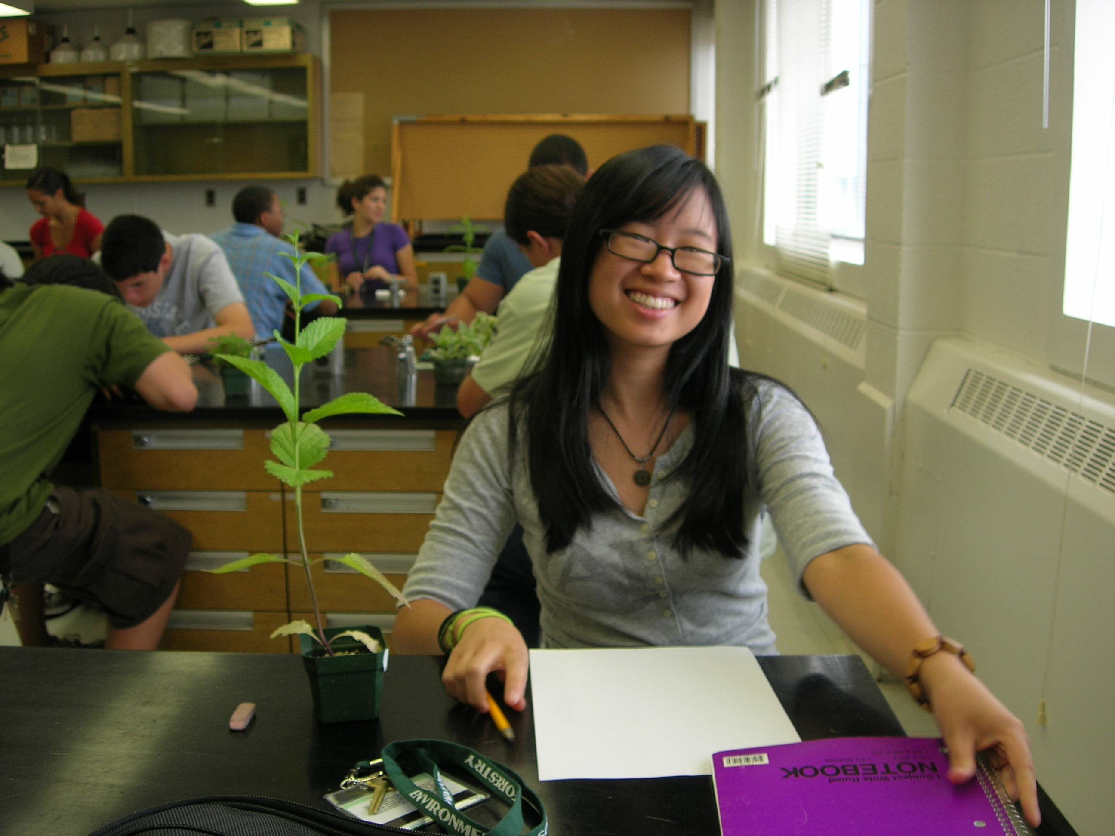
311 Walters Hall, 470-6525

Dr. Charles Hall, Environmental and Forest Biology, 354 Illick
Hall, 470-6870

Mr. Warren Hellman, Environmental and Forest Biology, 106
Illick Hall, 470-6768

Professor Dawnelle Jager, Writing Program,
105 Moon Library, 470-6722

Dr. Don Leopold, Chair – Environmental and Forest Biology
241 Illick Hall, 470-6743

Ms. Liz Mix, Service Learning, 413B Bray Hall,
470-4909

Mr. Chris Pedley, Programmer/Analyst, Administrative
Computing 22 Bray Hall, 470-6946

Ms. Heather Rice, Counseling & Disability Services
110 Bray Hall, 470-6658

Dr. Neil Ringler, Dean, Research Programs
200 Bray Hall 470-6606

Dr. Cynthia Sedgwick, Dean, Student Life and Experiential
Learning, 203 Bray Hall, 470-6658

Pre-Orientation Peer Advisors

Mr. Andrew Chan

Ms. Leticia Izquierdo

Ms. Brittany Meeks

Ms. Leetha Phonharath

Sponsored by the Offices of Multicultural Affairs
& Student Life and Experiential Learning

Pre-Orientation
2009

Preparing for Success
at SUNY-ESF

August 16-26, 2009

