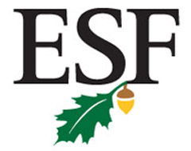
State University of New York
College of Environmental Science and Forestry
Office of Instruction & Graduate Studies

Memorandum

Date: June 4, 2010
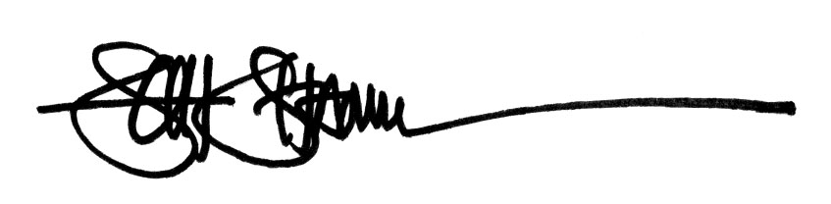
To: Bruce Bongarten, Provost
From: Scott Shannon, Dean I&GS:

Status Report: Programs up for review by SUNY and NYSED as approved by COI in Spring 2010

The following degree programs, both new and those existing programs with major revisions have been approved by the College’s Faculty Governance - Committee on Instruction (COI) during the spring 2010 semester, but will not be added to the College Catalog or available for entering students until Fall 2011. Each is now in various stages of review or preparation for review as required by SUNY and/or NYSED:
- AAS in Environmental and Natural Resources Conservation (Ranger School) – new degree program. Status: SUNY System program announcement and comment period completed successfully. Final proposal new in preparation stages, to be submitted prior to July 1 for SUNY/NYSED final review.
- MPS in Sustainable Engineering Management – new program designed to CGS PSM specification. Status: PSM designation approved by CGS in March 2010. Letter of Intent submitted for SUNY comment submitted in early April; waiting on final comments from SUNY System prior to final submission. Anticipate final submission prior to July 15 for SUNY/NYSED final review.
- BS in Environmental Resources Engineering – revised undergraduate degree program (new title, changed from existing “Forest Engineering”). Status: Major revision submission being prepared as directed using SUNY “Appendix E” program review guidelines; preliminary submission to SUNY made June 1 and awaiting comments.
- MS and PhD in Paper and Bioprocess Engineering – new independent degree programs disaggregated from the existing MS and PhD in Environmental and Resources Engineering degree titles. Status: Major revision submission being prepared as directed using SUNY “Appendix E” program review guidelines; submission anticipated by June 15
- MPS, MS, and PhD in Sustainable Construction Management and Wood Science – new independent degree programs disaggregated from the existing MPS, MS, and PhD in Environmental and Resources Engineering degree titles. Status: Major revision submission being prepared as directed using SUNY “Appendix E” program review guidelines; submission anticipated by June 15
- MPS, MS, and PhD in Environmental Resources Engineering – new independent degree programs disaggregated from the existing MPS, MS, and PhD in Environmental and Resources Engineering degree titles. Status: Major revision submission being prepared as directed using SUNY “Appendix E” program review guidelines; submission anticipated by June 15

