**Project Approach**

Air pollutants such as nitrogen oxides, sulfur dioxide, and mercury have had significant impacts on the quality of lakes, rivers, soils, and tree health throughout the Northeast. Some parts of New York State are particularly susceptible to environmental degradation, such as the Adirondack and Catskill regions, which receive some of the highest rates of atmospheric deposition in the country. NYSERDA’s Environmental Research program has supported long-term environmental monitoring in New York State, as have many other agencies. The data sets produced by these efforts have been extremely valuable for evaluating changes over time in air pollution loads and effects on the environment.

In this project, we will assess the efficiency and coverage of the current environmental monitoring programs. With guidance from the PAC, we will survey the available data sets, document what data are available, and identify redundancies and gaps. We will also identify the science and policy questions that depend on information from these environmental monitoring efforts. These initial investigations will require communications with larger stakeholder groups, for which purpose we will organize workshops at the biennial EMEP meeting, as described in the Schedule below, as well as communicating with individuals and organizations leading up to that meeting.

After documenting what data are available and identifying the policy needs for environmental monitoring, we can begin to analyze whether current monitoring practices are excessive (requiring more effort than is justified by the results produced) and/or inadequate (producing results that are not sufficiently accurate or precise to meet policy needs). We will select the specific data sets to be analyzed in cooperation with the PAC, but anticipate sequencing our efforts to analyze the most important monitoring programs for atmospheric deposition, streams, lakes, terrestrial biota, and soils.

Informed by our experience with the network for Quantifying Uncertainty in Ecosystem Studies (QUEST), our approach to evaluating monitoring efficiency involves a comprehensive assessment of the sources of uncertainty in environmental monitoring, including natural variation, measurement error, and model selection.

Natural spatial and temporal variation in environmental systems can be very high, such that confidence in an estimate is limited by sampling density or frequency. For example, the carbon content of soils is so spatially variable that current sampling methods cannot produce estimates of change over time that are adequate to meet policy needs for carbon accounting; for this reason soils are commonly omitted from carbon offset programs. In contrast, precipitation amounts are quite consistent spatially; a Monte Carlo sampling analyses of the 25 precipitation collectors at Hubbard Brook shows this sampling density to be excessive relative to policy needs (up to 5 collectors could be removed without increasing the uncertainty in the estimate of precipitation volume). A similar spatial approach could be used to determine how many Adirondack lakes are required to accurately estimate trends in acid deposition effects in the region.

Measurement error, likewise, is important in components of some systems but not in others. For example, uncertainty in the analysis of chemical constituents of stream water is small compared to the uncertainty in discharge, especially at very high volumes. Blowing snow and groundwater fluxes are very difficult to measure and contribute uncertainty in hydrologic budgets where they are large in magnitude. In most cases, measurement error is well known or relatively easy to estimate.

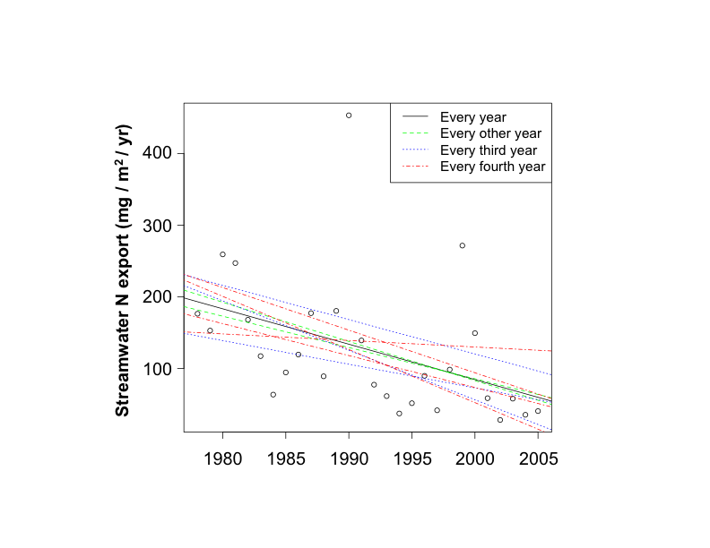

Figure 1. Annual export of N from Hubbard Brook W6 (black circles) and regressions based on all years or subsamples of all years.

Model selection error can be very important but is often overlooked. In estimating forest biomass, propagating uncertainty in the allometric equations describes the variation in the sample used to estimate the equations. This source of uncertainty may be quite small (5% in the case of Whittaker’s equations applied at Hubbard Brook), while the consequence of choosing which allometric equations to apply can result in an uncertainty of 30% in total biomass. In the case of stream export of nutrients, the approach of multiplying weekly concentration by weekly discharge can be compared to more sophisticated models that use more variables to evaluate the error introduced by model selection.



Figure 2. Uncertainty in the slope of stream N export over time for various sampling intensities.

We used stream export of N at Hubbard Brook to illustrate the application of uncertainty analysis to modeling efficiency. The reported decline in N export would be similar if the stream were monitored only in alternate years (Figure 1). However, the uncertainty in the slope of the regression increases as monitoring frequency is reduced (Figure 2). Whether a larger uncertainty is acceptable depends on the needs of the research and policy users of these data. Another option for reducing sampling effort would be to reduce sampling frequency within years, but this approach carries a risk of missing important changes in seasonal variation. We can also test the effects of changes in monitoring intensity using a non-parametric statistical approach, such as the Seasonal Kendall test for trend.

We will consult with the PAC to select data sets for detailed analysis and refine the objectives for the analyses. The richness of the long-term data sets makes it possible to simulate reduced sampling designs and also to identify the sites most important to continue monitoring. As appropriate, we will quantify the uncertainty due to natural variation and sampling design, measurement error, and model selection, and identify which aspects of selected environmental monitoring programs should be expanded or reduced to improve monitoring efficiency in the context of science and policy needs.

**Schedule of Activities and Products**

***July 2011:*** PAC advises on the overall approach, the relevant data sets, and the stakeholders to contact for data documentation and for input on policy needs.

***July-November 2011:*** Conduct a census of existing monitoring programs. Assemble metadata on a website, hosted by NYSERDA, QUEST, or the best alternative. Begin quantitative analyses.

***November 2011:*** Present a preliminary report on existing monitoring programs to stakeholders at the EMEP meeting, identifying coverage, opportunities, redundancies, and gaps.

***November 2011:*** Identify deposition thresholds and detection limits desired as outcomes of environmental monitoring, via a policy workshop, held in conjunction with the EMEP meeting.

***November – July:*** Complete the quantitative evaluation of efficiency of selected monitoring programs, sequenced to allow reporting of recommendations for the following topic areas.

***January 2012:*** Atmospheric deposition; ***March 2012:*** Streams; ***May 2012:*** Lakes; ***June 2012:*** Terrestrial biota; ***July 2012:*** Soils. Each report will include a summary of monitoring efforts to date, recommendations for improving monitoring efficiency, and potential applications of the data.

***August 2012:*** Workshop to present findings to stakeholders and discuss implications.

***September – December:*** Preparation of articles on monitoring efficiency for regional and international audiences.

Final products will include a report to be submitted to the advisory committee, at least one manuscript for publication in a peer-reviewed journal, and an improved understanding of issues relating to monitoring efficiency among researchers, managers, and policy-makers.