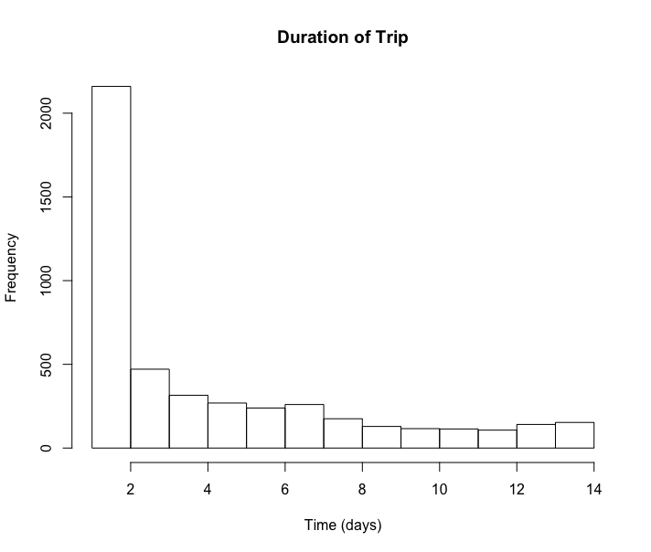

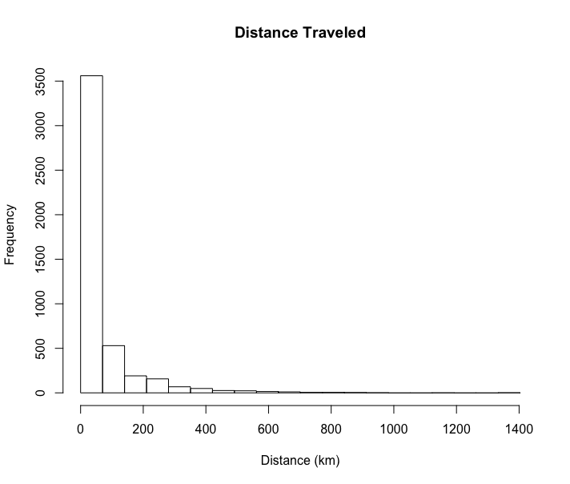

Summary Stats for Trip Duration and Distance

|  |  |  |  |  |  |  |  |
| --- | --- | --- | --- | --- | --- | --- | --- |
|  | Min | 5% | 1st Qu | Median | Mean | 3rd Qu | Max |
| Distance (km) | 1.00 | 1.00 | 1.00 | 3.00 | 4.40 | 7.00 | 14.00 |
| Time (days) | 0.00 | 0.00 | 1.01 | 16.20 | 59.47 | 63.82 | 1403.25 |