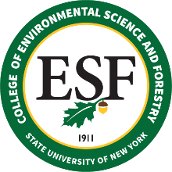
ESF Board of Trustees
Meeting & Event Schedule
2021 - 2022

ESF Board of Trustee Meetings

2021
January 15 (virtual)
May 14 (in-person & virtual)
September 24
December 10

2022
February 25
May 6
September 23
December 9

Board Committee Meetings

2021

Diversity, Equity and Inclusion Committee
May 5, 2021 @ 10 AM

Governance Committee
March 16 @ 12:30 PM

Sustainable Finance Committee
January 7 @ 4 PM
April 29 @ 10 AM

Sustainable Operations Committee
Date – time, TBD

Other Upcoming ESF Events

2021 Earth Week Activities – https://www.esf.edu/earthweek/
April 18-24

2021 Commencement
May 13 – Scholars Reception
May 15 – ESF Commencement
May 15 – Ranger School Graduation
December 10 – December Commencement

2021 Feinstone Environmental Awards Banquet
May 20 @ 7 PM, virtual ceremony

2021 Homecoming/Reunion Weekend (https://www.esf.edu/alumni/homecoming/)
October 28-30

2021 Family Fall Weekend
October TBD

ESF Master Calendar: https://www.esf.edu/calendar/
(Please visit the link above for a listing of daily events.)

ESF Alumni Association Calendar of Events: https://www.esf.edu/calendar/alumni.asp

