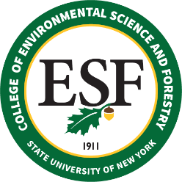

BOARD OF TRUSTEES MEETING
Friday, May 14, 2021

PROPOSED RESOLUTION

RESOLVED that (a) the following individuals be recommended for Continuing Appointment:

Mary Collins
Associate Professor – 10 Months
Environmental Studies
September 1, 2021

Hyatt Green
Associate Professor – 10 Months
Environmental Biology
September 1, 2021

that (b) the following individuals be recommended for Permanent Appointment:

Lauren Polak Kwaczala
Assistant Director of Admissions
Undergraduate Admissions
February 16, 2022

that (c) the following individuals be recommended for Emeritus Status:

Wendy Osborne
Assistant Director of Community Relations
Communications and Marketing
January 23, 2021

Maureen Fellows
Vice President for Government and External Relations
Governmental Relations and Institutional Planning
February 1, 2021

Anthony Miller
Instructor – 10 Months
Landscape Architecture
May 21, 2021

Neil Ringler
Associate Provost
Office of Research Programs
July 2, 2021

that (d) the following individuals be recommended for Sabbatical Leave:

SABBATICAL LEAVE, TITLE E

Emanuel Carter
Associate Professor – 10 Months
Landscape Architecture
Fall 2021 Semester
At Full Salary
S. Scott Shannon
Dean
Office of Instruction & Graduate Studies
December 15, 2021 – June 15, 2022
At Full Salary

Ivan Gitsov Ivanov
Professor – 12 Months
Chemistry
February 1, 2022 – May 31, 2022
At Full Salary

Douglas Johnston
Professor – 12 Months and Chair
Landscape Architecture
January 1, 2022 – July 1, 2022
At Full Salary

TITLE F LEAVE – (none to report)

