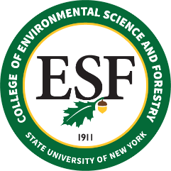

BOARD OF TRUSTEES MEETING
Friday, February 25, 2022

PROPOSED RESOLUTION

RESOLVED, that, upon the recommendation of faculty, the Provost, and the President of the College of Environmental Science and Forestry, this Board of Trustees recommends that, at the May 2022 commencement, the degree of Bachelor of Science in Environmental Studies, shall be conferred, posthumously, upon Troy I. Eames, as this student satisfactorily completed the requirements of such degree and was in good standing.

