Ragan A. Squier
ESF Board of Trustees
Secretary to the Board

M E M O R A N D U M

TO: Members of the ESF Board of Trustees
Diversity, Equity and Inclusion Committee
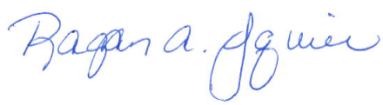
FROM: Ragan A. Squier
Secretary to the Board

DATE: January 27, 2022

SUBJECT: Official Notice of the February 2, 2022 Diversity, Equity, and Inclusion Board Committee Meeting

Please be advised that a meeting of the ESF Board of Trustees Diversity, Equity and Inclusion Committee will be held on Wednesday, February 2, 2022, at 9 AM via videoconference and livestreamed to the public.
224 Bray Hall | 1 Forestry Drive | Syracuse, N.Y. 13210 U.S.A. | P. 315.470.6681 | F. 315-470-6977 | president@esf.edu | esf.edu

Wednesday, February 2, 2022
9:00 AM Diversity, Equity and Inclusion Board Committee Meeting
Location: videoconference

Livestream address: https://www.esf.edu/welcome/trustees.htm

