Ragan A. Squier
ESF Board of Trustees
Secretary to the Board

M E M O R A N D U M

TO: Members of the ESF Board of Trustees
Diversity, Equity and Inclusion Committee
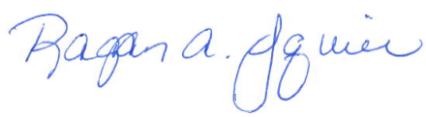
FROM: Ragan A. Squier
Secretary to the Board

DATE: April 6, 2022

SUBJECT: Official Notice of the April 14, 2022 Diversity, Equity, and Inclusion Board Committee Meeting

Please be advised that a meeting of the ESF Board of Trustees Diversity, Equity and Inclusion Committee will be held on Thursday, April 14, 2022, at 10 AM via videoconference and livestreamed to the public.
224 Bray Hall | 1 Forestry Drive | Syracuse, N.Y. 13210 U.S.A. | P. 315.470.6681 | F. 315-470-6977 | president@esf.edu | esf.edu

Thursday, April 14, 2022
10:00 AM Diversity, Equity and Inclusion Board Committee Meeting
Location: videoconference

Livestream address: https://www.esf.edu/welcome/trustees.htm

